Specific Facilities for Women

Counselling session with School children

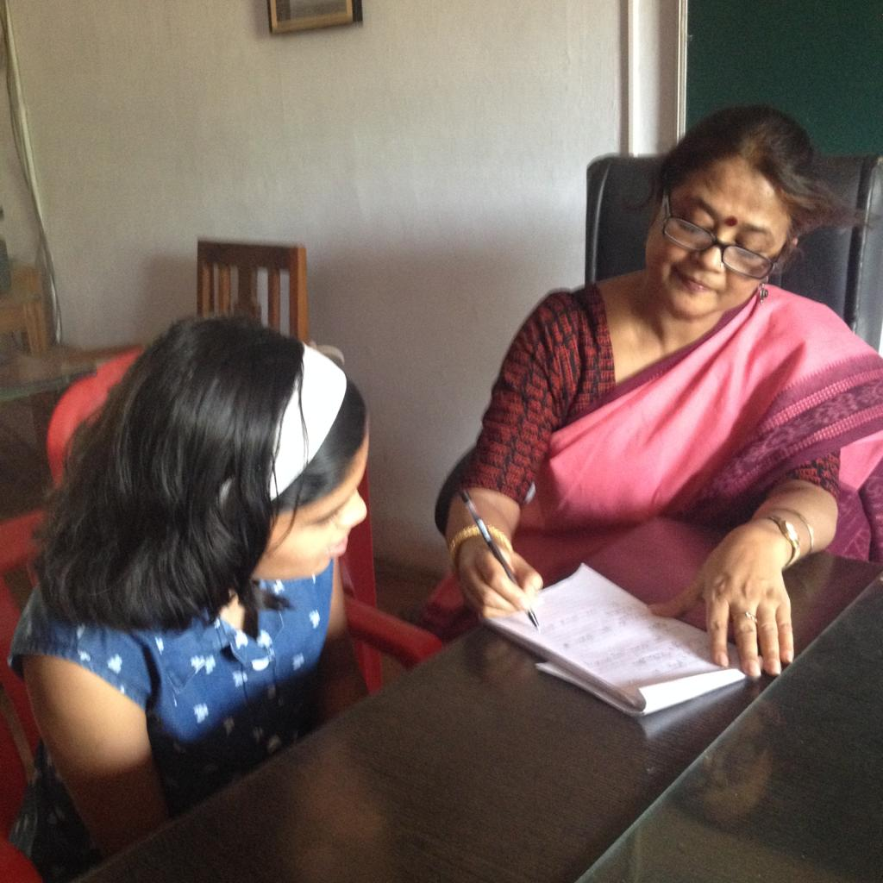

Counselling session with College Students

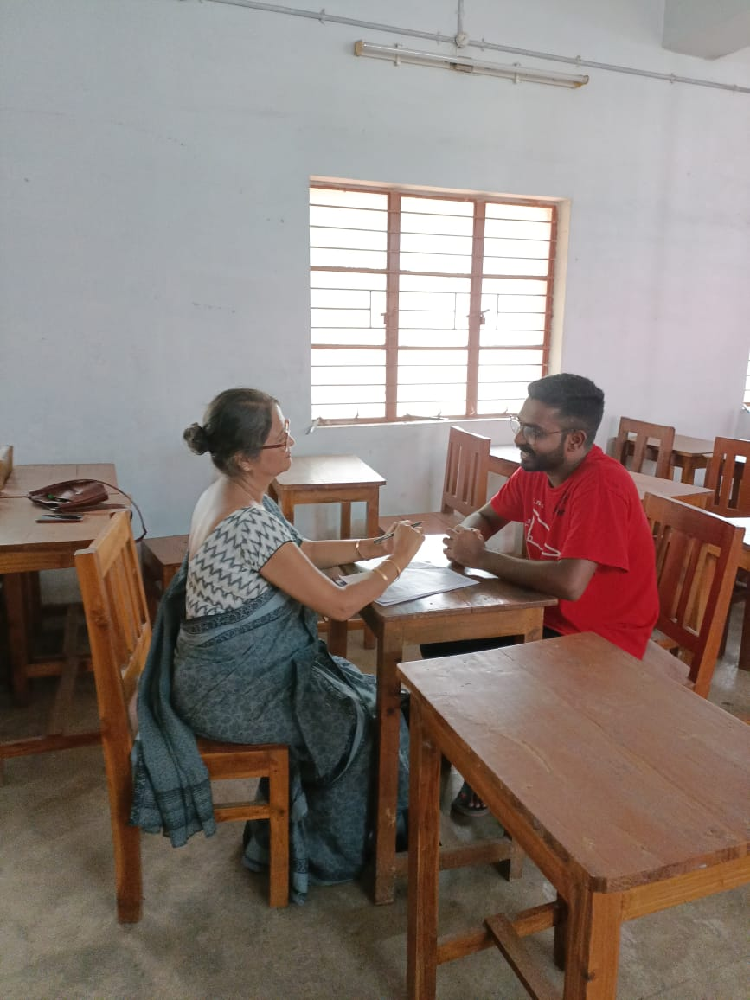

CCTV in front of Main Gate of the College

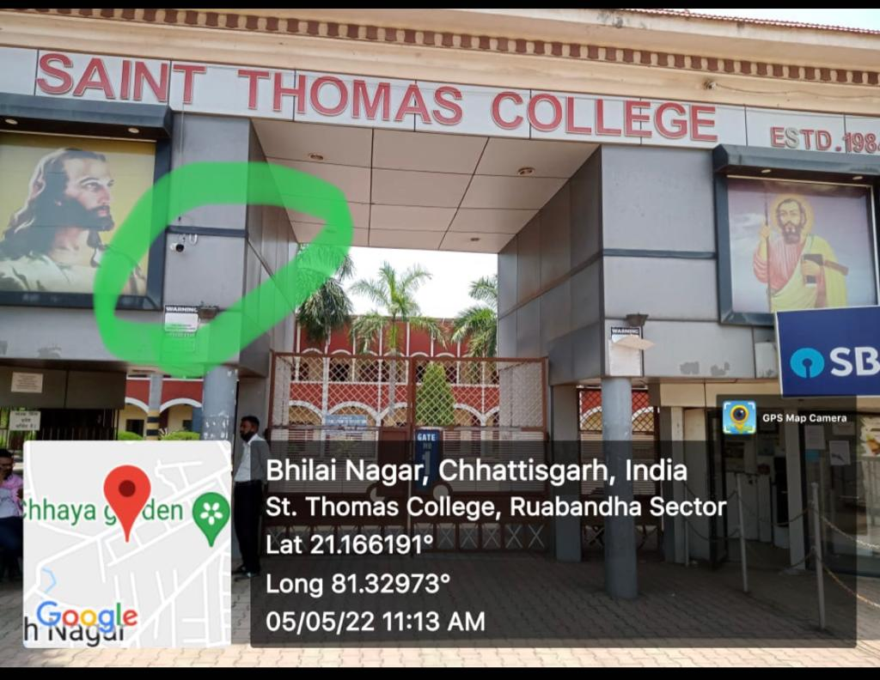

CCTV in front of St. Mary’s Girls Hostel
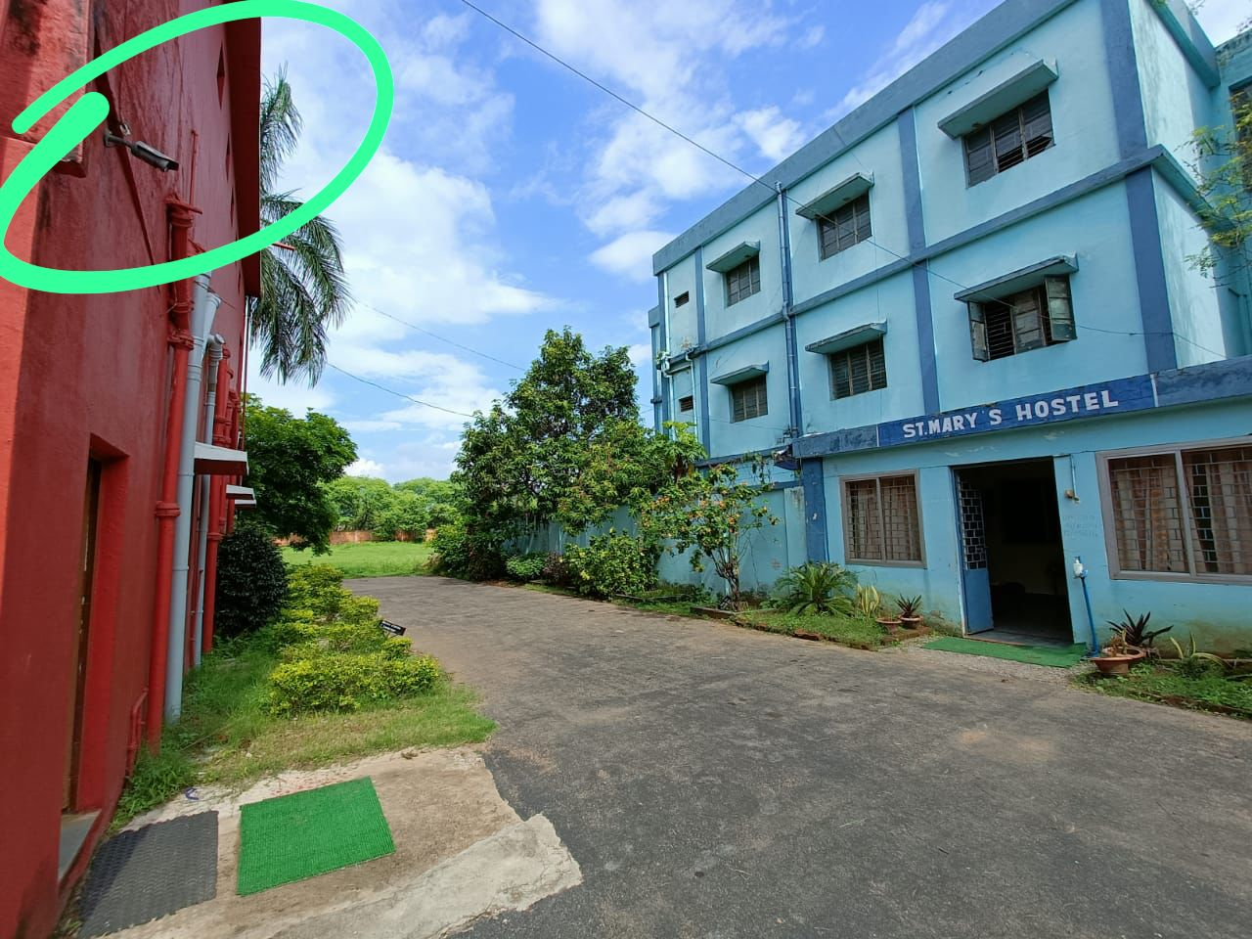

Girls Common Room in MTB Block of the College.

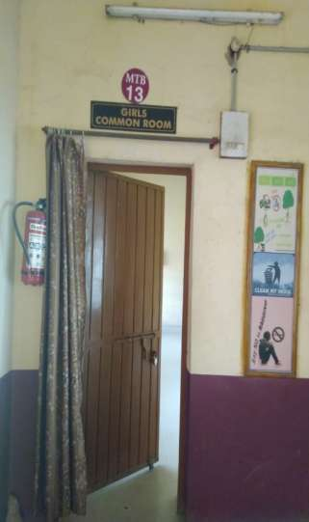

Napkin Wending Machine in Girls Common Room

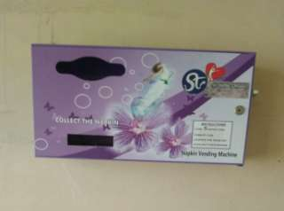

Health Centre

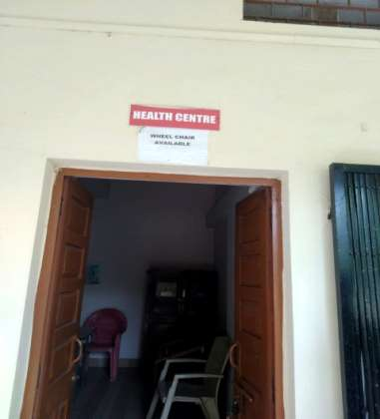

Medical Check Up for Hostel Inmates

Female Security Personnel in Gate No 2 of the College.

