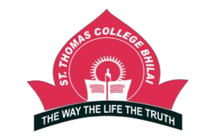
ST. THOMAS COLLEGE, BHILAI
Annual Gender Sensitization Action plan
Academic Year: 2021– 22

S.N | Event | Day and Date | Title | Number of Beneficiaries | Pictures
1 | Webinar | 13.08.2021 Friday | Role Of Women in modern era | 40
 |  |  |  |  | 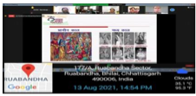
2 | Webinar | 31.08.2021 Tuesday | Management of Personal Health and Hygiene | 191 | 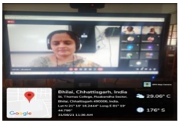
3 | Awareness Programme on Third Gender | 20.11.2021 Saturday | Observing Transgender Day of Remembrance | 186 | 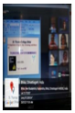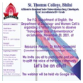

4 | Counselling session | 27.11.2021 Saturday | Counselling session for Hostel Inmates | 80 | 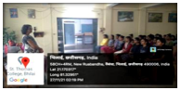
5 | Guest Lecture | 4.12.2021 Saturday | Guidelines of Vishakha Act Against Women Abuse by Advocate Ajeet Paul, Criminal Lawyer, District Court, Durg, Chhattisgarh | 60 | 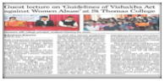
6 | Special NSS  Camp | 4.1.2022 Tuesday | Covid Awareness, Session on Good Touch and Bad Touch for Children and BETI BACHAO BETI PADHAO | 50 | 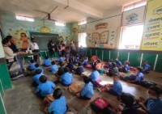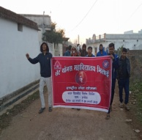50
7 | Online Poster Making Competition | 24.1.2022  Monday | “Save Girl Child” to celebrate National Girl Child Day | 15 | 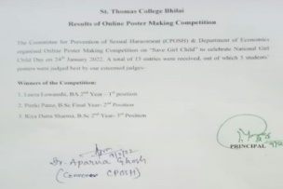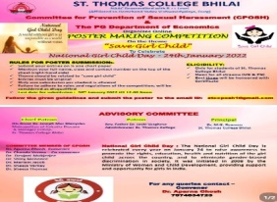
8 | Celebrating International Women’s Day | 8.3.2022  Tuesday | PPT was done on Indian feminist writers. The theme  of the celebration was Indian feminist writers: Breaking the Glass ceiling | 25 | 