Criterion - 6 :Governance, Leadership and Management

6.5 : Internal Quality Assurance System

6.5.1 : Internal Quality Assurance Cell (IQAC) has Contributed Significantly for Institutionalizing the Quality Assurance Strategies and Processes

IQAC Initiative – Mainstreaming Cross Cutting Issues in Syllabus

https://www.stthomascollegebhilai.in/IQAC/AQAR-21-22/criterion_i/1.3.1_Description_of_Courses.pdf
Celebration of Important Days

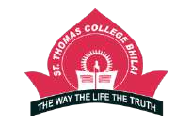
ST. THOMAS COLLEGE, BHILAI
Academic Year : 2021 – 22

Sl No. | Commemoration of National / International Day | Date | Event / Activity Organised | Pictures
1 | World Environment Day | 5th June, 2021 | National Webinar on “Ecosystem Restoration” | 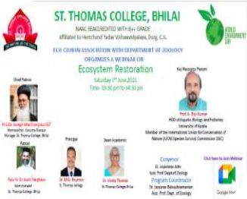
2 | Vishva Paryavaran Diwas | 5th June, 2021 | Essay Competitions | 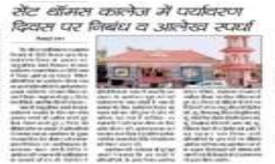

3 | International Yoga Day | 21st June, 2021 | Virtual Yoga Day Session | 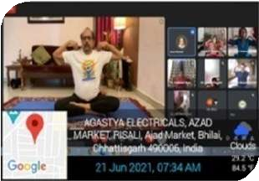
4 | Independence Day | 15th August, 2021 | Flag hoisting with thought provoking speeches
5 | National Counselling Psychology Day | 17th August, 2021 | Career Counselling Session
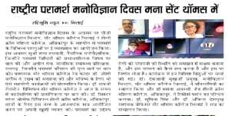

6 | World Photography Day | 19th August, 2021 | Online Mobile Photography Contest  “Click it 2” Theme: Sports | 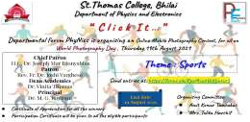
7 | National Nutrition Week | 2nd to 8th September, 2021 | Webinar
8 | Teacher’s Day Celebration | 5 September, 2021 | NSS Volunteers did Tree Plantation | 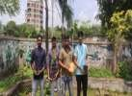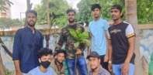
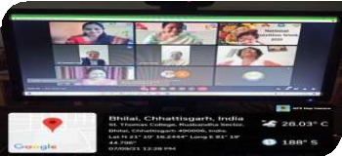

9 | International Literacy Day | 8th September, 2021 | Webinar
10 | World Literacy Day | 8th September, 2021 | Speech Competition and Quiz Competition
11 | Hindi Diwas | 14th September 2021 | Kavitha Pathan Pratiyogita | 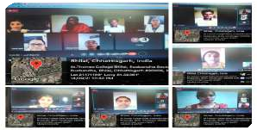
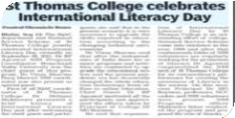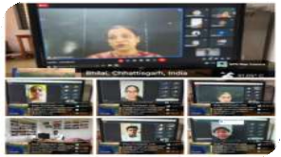

12 | International Democratic Day | 15th September, 2021 |  | 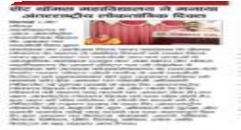
13 | World Ozone Day | 16th September, 2021 | Poster Competition on “No Ozone, No Life” | 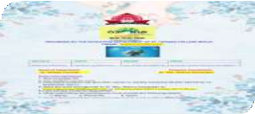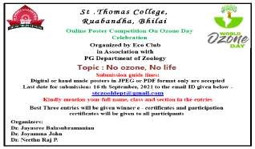
14 | International Day of Peace | 21st September 2021 | Online Essay writing Competition ("Recovering better for an equitable and sustainable world") and song competition | 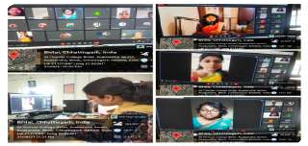

15 | Sigmund Freud Death Aniversary | 23 September,  2021 | Webinar | 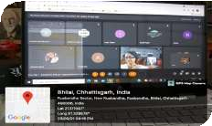
16 | Right to Know Day | 28th September 2021 | Essay Competition | 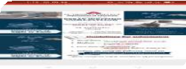
17 | International Day of Older Persons | 1st October, 2021 | Express your views -- video upload | 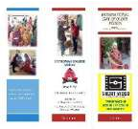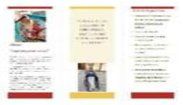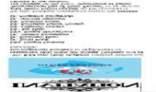

18 | International Day of Non-Violence | 2nd October, 2021 | Sketch Competition | 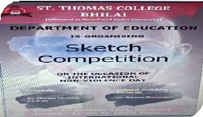
19 | Gandhi Jayanti and Lal Bahadur Shastri Jayanti | 2nd October, 2021 | Visit to Nayandeep School (Blind Children) at Bhilai
20 | World Mental Health Day | 9th October, 2021 | Online Paper Presentation
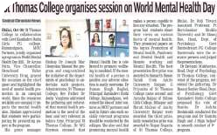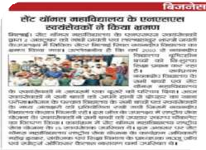

21 | National Unity Day | 31st October, 2021 | Poster Making Competition | 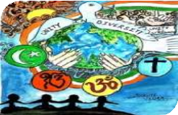
22 | World Legal Service Day | 9th November, 2021 | Online Guest Lecture on 'Provisions for Women Protection under Vishakha Act 2013' | 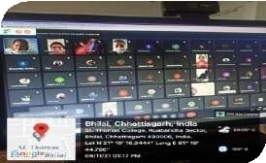
23 | World Immunization Day | 10th November, 2021 | On-the-Spot Poster making Competition | 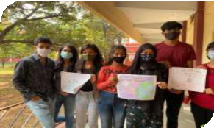

24 | World Pneumonia Day | 12th November, 2021 | Quiz Competition | 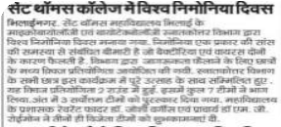
25 | International Students Day | 17th November, 2021 | Scrap Book Competition and Best out of Waste | 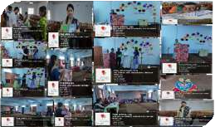
26 | Transgender Day of Remembrance | 20th November, 2021 | Webinar  Speaker : Dr. Nisha Goswami (Consultant) Psychotherapist & Psychologist, Bhilai, (C.G)
27 | World Fisheries Day | 21st November, 2021 | PPT Competition | ST . THOMAS COLLEGE  RUAB ANDH A, B H IL AI  Affiliated to Hemchand Yadav Vishwavidyalaya, Durg, Chhattisgarh NAAC Accreditated at B++ Grade  The PG department of Zoology Organizes  An Online Power Point Video Presentation Competition On  !Sc$%& $( )*+a-&+ta/ 0123 (a*-1+4 1+ 5+61a”  On The Occasion Of  “WORLD FISHERIES DAY”  On 21St. November,2021  Interested students have to prepare a PPT Video and mail it to stc.zooldept@gmail.com  Chief Patron: H.G.Dr.JosephMar Dionysius on 21.11.2021 positively  First three position winners will be given certificate of achievement All participants will be issued Certificates of participation  OrganizingCommittee:  Convenor: CoConvenors:  Dr. JayasreeBalasubramanian Dr. Joyamma John  ( Head,Department of Zoology) Dr. NeetuRaj Panickar  Patron: Rev.Fr.Joshi Varghese Principal:Dr. M.G.Roymon
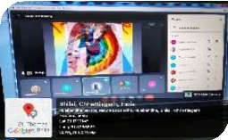

28 | National Constitution Day | 26th November, 2021 | Youth Awareness Towards Constitution  & Awareness Rally | 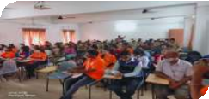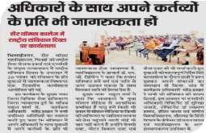
29 | NCC DAY | 26th November, 2021
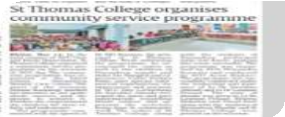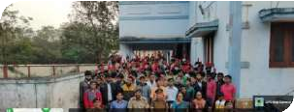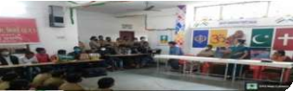

30 | World AIDS Day | 1st December, 2021 | Poster & Quiz Competition | 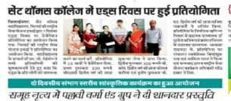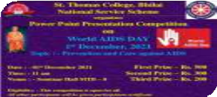
31 | World Computer Literacy Day | 6th December, 2021 | St. Thomas College Celebrated Golden Jubilee Celebration Of St.  Thomas Mission & World Computer Literacy Day | 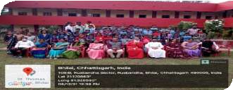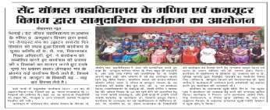

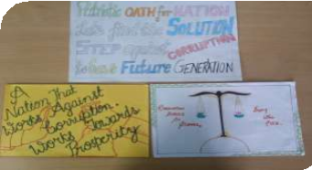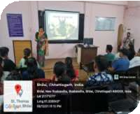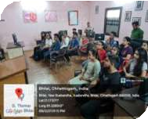

32 | Birth Anniversary of John Milton | 9th December, 2021 | PPT highlighting Miltons Life and elucidating his famous poem ‘Paradise Lost’
33 | International Anti Corruption Day | 9th December 2021. | Slogan Writing Competition, Vigilant India - Prosperous India | 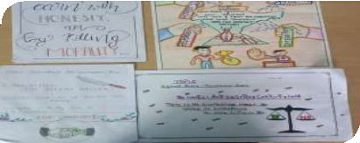
34 | World Human Rights Day | 10th December, 2021 | Webinar  Speaker: Dr. Manjeet Kaur | 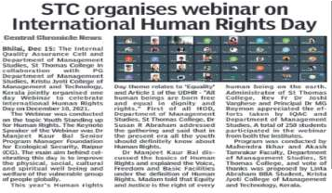

35 | Road safety | 15th December, 2021. | 'One day Awareness program | 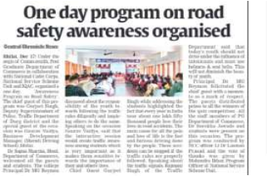
36 | SVEEP | 17th December, 2021 | Oath Taking for Voter Awareness under SVEEP | 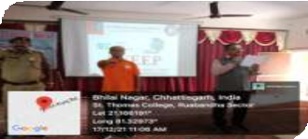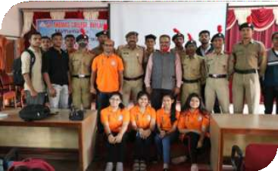

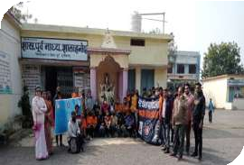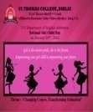

37 | Farmers Day | 23 December 2021 | Online Slogan Writing and Poster Making Competition
38 | Awareness Program | 31st December, 2021 | for creating awareness about Fundamental Duties of Constitution
39 | Celebrating National Girl Child PPT on theme of Girl Child day | 24th January, 2022 | Celebrating National Girl Child PPT on theme of Girl Child day- Changing Course, Transforming education
40 | Republic Day | 26th January, 2022 | Republic Day | 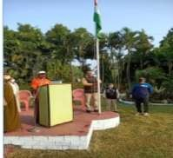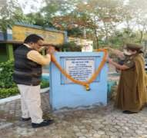

41 | World wetland day | 2nd February, 2022 | Oratory competition for school and college students on  World wetland day | 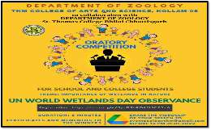
42 | Darwin’s Day Celebrations | 12th February, 2022 | National Webinar On Darwin’s Day Celebrations | 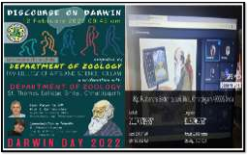
43 | National Science Day | 26th February, 2022 | Rangoli Competition on the occasion of National Science Day (Science in Rangoli) | 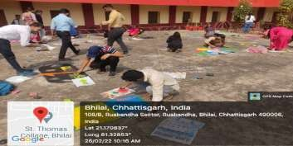
44 | National Science Day | 28th February, 2022 | Slogan writing and Poster making competition | 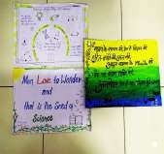
45 | International Science Day | 28th February, 2022 | Poster competition on International Science Day | 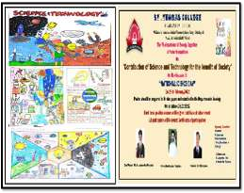

46 | International Women’s Day | 8th March, 2022 | International Women’s Day Celebration
47 | “World Consumer Rights Day” | 15th March, 2022 | Guest Lecture(Under MOU)St. Thomas College Bhilai &Govt. V Y T Autonomous College Burg(Dept of Economics) | 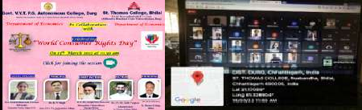
48 | International Day Of Forests | 21st March, 2022 | National Webinar On International Day Of Forests | 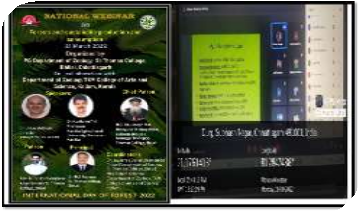
49 | World Theatre Day | 29th March, 2022 | National Webinar (World Theatre Day) | 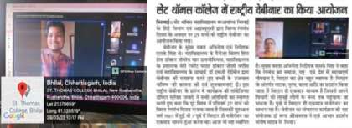

50 | World Health Day | 7th April, 2022 | World Health Day | 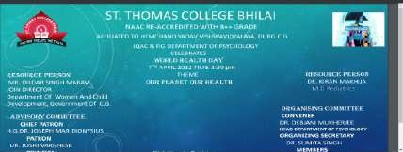
51 | Earth Day | 22nd April, 2022 | Earth Day Online Programme | 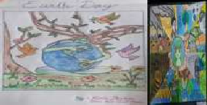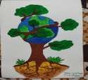
52 | Celebrating Rabindranath Tagore Jayanti | 9th May, 2022 | 1A short biography about his life and influences through documentary  - Poetry Narration (Gitanjali) by the students  - Rabindra Sangeet performed by the students | 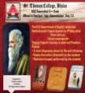
53 | Common Wealth Day | 24th May, 2022 | PPT Presentation Competition
 |  |  |  | 