Criterion - 6 : Governance, Leadership and Management

6.2 : Strategy Development and Deployment

6.2.1 : The Institutional Strategic / Perspective Plan is Effectively Deployed

Permission Letter for Research Centre
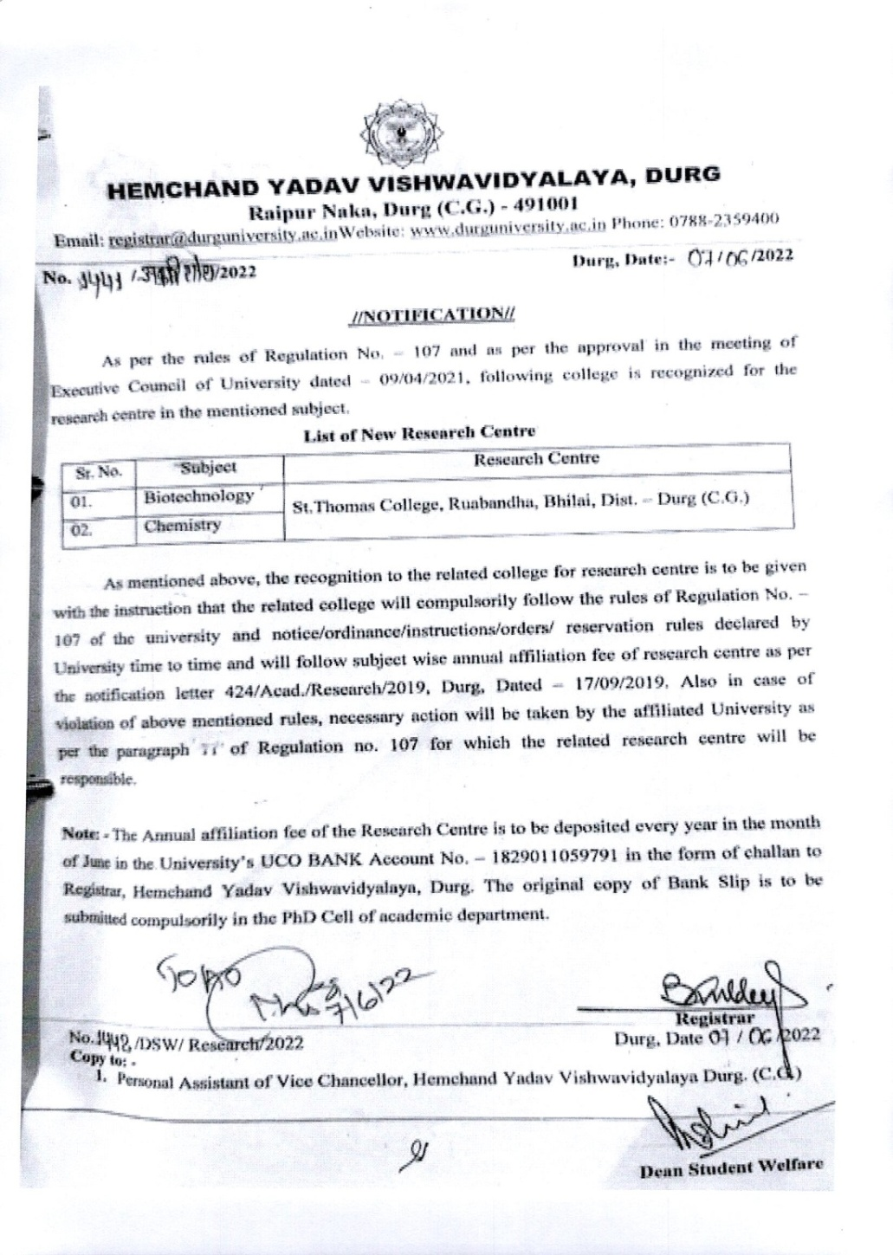

New Course introduced – Affiliation Letter
Seat Increase – Permission Letter
