**St. Thomas College, Bhilai**



***Affiliated to Hemchand Yadav Vishwavidyalaya, Durg, Chhattisgarh***

Criterion – 4

* + 1. **4.4.2: Systems and Procedures for Maintaining and Utilizing Physical Academic and Support Facilities – Laboratory, Library, Sports Complex, Computers, Classrooms Etc.**

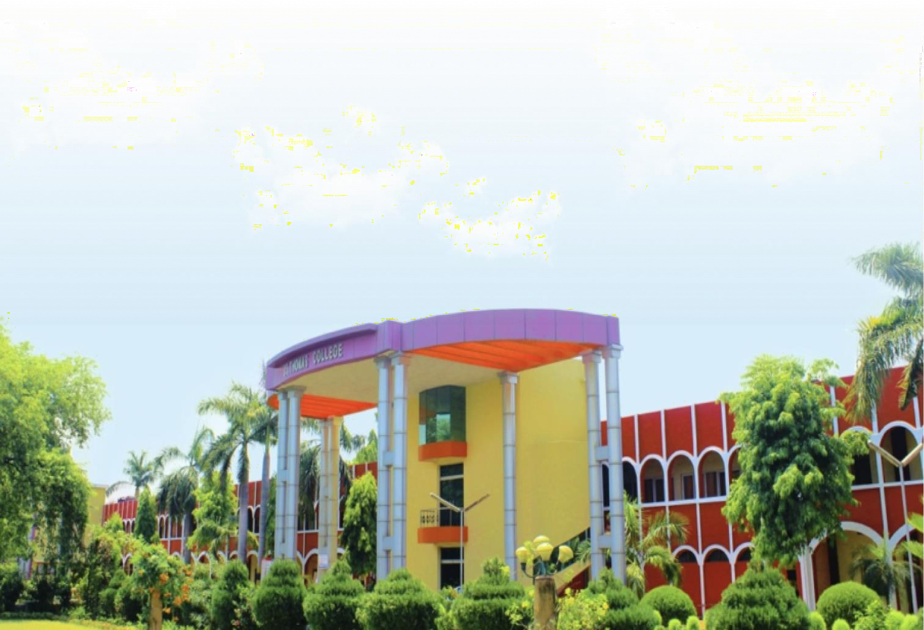

Submitted to National Assessment and Accreditation Council 2021-22

* + - * **Additional Information**

**Procedure for utilization of Physical facilities**

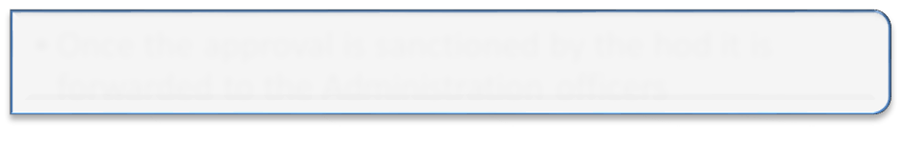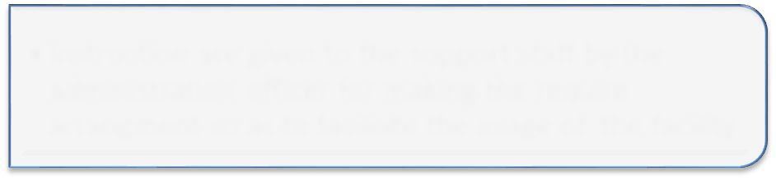

1

* Request To HOD for the utilization of the facility

2

* Once the approval is sanctioned by the hod it is

forwarded to the Administration officers

3

* The request is recorded in a register and if the facility

is available then it is permitted to utilize

4

* Instruction are given to the support staff by the

Administration officer for making the require

arrangement so as to facilitate the usage of the facility

**Procedure for Major Maintenance Works**

1

2

3

4

* Request revived by the Principal and forwarded to the Administrator

seeking approval .

* Request reviewed by the HOD and forwarded to the Principal seeking approval
* Request Placed to the concerned HOD seeking approval
* Identification of major Maintenance or Repair works.



Procedure for Repairs & Maintenance

**STEP 1**

* As and when it is Identify that any

infrastructure / assets / equipment requires repair/ maintenance , a request is recorded in the register specified , maintained by the administration office

**STEP - 2**

* The same register is regularly checked

by the In - house maintenance staff to attend to any repair/ maintenance work such as civil , electrical , plumbing , IT etc

.

AUDITED STATEMENT

