

**St. Thomas College, Bhilai**

**Committee of Promotion to Research Activity**

**Activity Report-2021-22**

**Day & Date:** 5 /8 /2021-19/8/2021Thursday

**Topic:** Research Methodology

**Activity:** Online certificate programme

**Number of Beneficiaries:** 38STC student 26 STC Staff

On line certificate programme was carried out jointly by COPRA and Department of Commerce, St. Thomas College, Bhilai.

Various speaker was given a lecture in this programme. Speakers shared their view and knowledge in this regards. For this program Dr. Asutosh was a key note speaker for inauration and Dr. Rajeev Choudhary is a chief guest for Valedictory session.

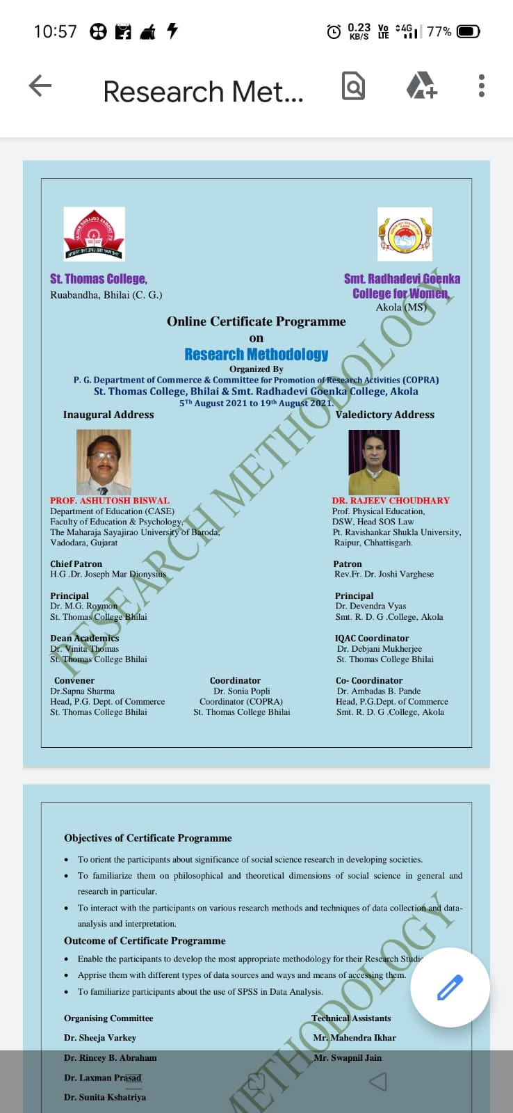



**St. Thomas College, Bhilai**

**COPRA Activity**

**Activity Report-2021-22**

**Day & Date:** 5 /8 /2021-19/8/2021Thursday

**Topic:** Research Methodology

**Activity:** Online certificate programme

**Number of Beneficiaries:** 38STC student 26 STC Staff

|  |  |  |  |
| --- | --- | --- | --- |
| **Email address** | **Name of Participant (Mr./Ms./Dr.)TO BE PRINTED ON THE CERTIFICATE** | **Designation** | **College/Organization** |
| bhatiasaminder28@gmail.com | Saminder kaur | Student | Saint thomas collagr Bhilai |
| shefaligoswami44@gmail.com | Ms. Sefali | Student | Saint Thomas college bhilai |
| Pragatikv109@gmail.com | Pragati | Student | Saint thomas college bhilai |
| mikety1995@gmail.com | Navneet Mehar | Student | Saint Thomas College Ruabandha Bhilai |
| mojjadausharani@gmail.com | Mojjada usharani | Student | St Thomas |
| Poojavermadgg@gmail.com | Pooja verma | Student | St thomas clg bhilai |
| 97dnishi@gmail.com | Ms. D NISHI | Student | St Thomas college |
| kabitasarkar75@gmail.com | Ms. KABITA SARKAR | Student | St Thomas College |
| shristi.panigrahi18@gmail.com | SHRISTI PANIGRAHI | Student | St Thomas College |
| Pragatibhagat07@gmail.com | Pragati bhagat | Student | St Thomas college |
| saxenae95@gmail.com | Ekta Saxena | Asist Prof | St thomas college |
| as.its.akanksha@gmail.com | Ms. Akanksha Singh | Student | St Thomas college |
| madhutirkey2705@gmail.com | Ms.Madhu Smita Tirkey | Student | St Thomas college Bhilai |
| Vibhutirana15@gmail.com | Vibhuti Rana | Student | St Thomas college bhilai |
| ncverma2@gmail.com | DR CHANDA VERMA | Asso Prof | St Thomas College Bhilai |
| jamesmathewstc@gmail.com | Dr James Mathew | Asso Prof | St Thomas College Bhilai |
| shikharmathurofficial@gmail.com | Shikhar Mathur | Student | St Thomas College Bhilai |
| ritunayak086@gmail.com | Ritu Nayak | Student | St Thomas college bhilai |
| mamtamandavi59385@gamil.com | Mamta Mandavi | Student | St Thomas college bhilai |
| ikharmahendra@gmail.com | MR MAHENDRA IKHAR | Assistant Prof | ST THOMAS COLLEGE BHILAI |
| stcsumitasingh@gmail.com | Dr Sumita Singh | Asist. Prof | St Thomas College Bhilai Chhattisgarh |
| priyanshushravan07460@gmail.com | Priyanshu shravan | Student | St thomas College ruabandha bhilai |
| riyaushasingh6260@gmail.com | Ms.Riya Singh | Student | St Thomas college, Bhilai |
| Surekhabhilai@gmail.com | Dr. Surekha Jawade | Assis. Prof | St Thomas College, Bhilai |
| Rutbaquraishi111@gmailcom | Rutba Qureshi | Student | St. Thomas College |
| neelamdarro1802@gmail.com | Neelam Darro | Student | St. Thomas clg bhilia |
| deeptisingh1096@gmail.com | Ms. Deepti Singh | Student | St. Thomas College |
| coolpuni91@gmail.com | Poornima Kujur | Student | St. Thomas college |
| deysonali166@gmail.com | Ms. Sonali Dey | Student | St. Thomas College |
| dl9273974@gmail.com | Divya Gulabi Lakra | Student | St. Thomas college |
| chetnasharma0203@gmail.com | Ms. CHETNA SHARMA | Assis. Prof | ST. THOMAS COLLEGE |
| amlaekka555@gmail.com | AMLA EKKA | Student | ST. THOMAS COLLEGE |
| marymekka@gmail.com | Mary Mridula Ekka | Student | St. Thomas College |
| shanti_162@rediffmail.com | Dr. V. Shanthi | Assi. Prof | St. Thomas college |
| digeshwarisahu80@gmail.com | Ms. Digeshwari Sahu | Student | St. Thomas College Bhilai, India |
| stcsujavarghese@gmail.com | Dr. SUJA VARGHESE | assistant professor | St. Thomas College Bhilai |
| pushpitasaha16@gmail.com | Pushpita Saha | Sgtudent | St. Thomas College Bhilai |
| singhaakanksha21@gmail.com | Aakanksha Singh | student | St. Thomas College Bhilai |
| rajoosahu1510@gmail.com | RAJKUMAR SAHU | Student | St. Thomas college Bhilai |
| shilpatoppo18@gmail.com | Shilpa Toppo | student | St. Thomas college bhilai |
| jaysree.stc@gmail.com | Dr. Jayasree Balasubramanian | assistant professor | St. Thomas College Bhilai |
| minich332@gmail.com | Monika chandrakar | assistant professor | ST. Thomas college bhilai |
| nehaverma1791@gmail.com | Ms. Neha Verma | assistant professor | St. Thomas College Bhilai |
| preetimadh26@gmail.com | Prof. Preeti Verma | assistant professor | St. Thomas College Bhilai |
| shilpatoppo18@gmail.com | Shilpa Toppo | student | St. Thomas college bhilai |
| www.durgeshnandini9600@gmail.com | Durgesh Nandini | Student | St. Thomas College Bhilai (C.G.) |
| vibhachoudhry1998@gmail.com | Vibha Choudhary | Student | St. Thomas College Bhilai Durg |
| ilaranisahu2000@gmail.com | ILARANI SAHU | Sgtudent | St. Thomas college bhilai, (C.G.) |
| 2bhuneshwarisahu@gmail.com | Bhuneshwari sahu | assistant professor | St. Thomas college Bhilai, ruabandha |
| 2903shaileshkumar@gmail.com | SHAILESH KUMAR CHANDRAKAR |  | ST. THOMAS COLLEGE RUAABANDHA BHILAI |
| Maju.joy.lic@gmail.com | Mr. J. MAJU | assistant professor | St. Thomas College Ruabanda Bhilai |
| purvipipariya741@gmail.com | Purvi Pipariya |  | St. Thomas college ruabandha bhilai |
| hariramsahu16@gmail.com | Mr. Hari Ram Sahu | assistant professor | St. Thomas College Ruabandha, Bhilai Chhattishgarh |
| tukendrasahu91@gmail.com | Mr. TUKENDRA KUMAR | Student | St. Thomas College Ruabandha, Bhilai, CG |
| pinku93000@gmail.com | Ms. Priyanka Singh | Student | St. Thomas College, Bhilai |
| nehatirkey299@gmail.com | Ms. Sabya Neha Tirkey | Student | St. Thomas College, bhilai |
| yasminhussain45@gmail.com | Ms Yasmin Hussain | Student | St. Thomas College, Bhilai |
| geetanjalibanchhor@gmail.com | Geetanjali Banchhor | Student | St. Thomas College, Bhilai |
| shubha2315@gmail.com | Dr. Shubha Diwan | assistant professor | St. Thomas College, Bhilai |
| sushipti2014@gmail.com | Ms. Sushipti Sen | Student | St. Thomas college, Bhilai |
| pinki280416@gmail.com | Bhunandanee deshmukh | Student | St. Thomas College, Bhilai |
| dikshadubey502@gmail.com | DIKSHA DUBEY | assistant professor | ST. THOMAS COLLEGE, BHILAI. |
| ry93590@gmail.com | MR. RAHUL KUMAR YADAV | Student | ST. THOMAS COLLEGE, RUABANDHA,BHILAI |
| Shwetasr99@gmail.com | Shweta Singh | Student | St. Thomas College,Bhilai |
| kunikajambhulkar02@gmail.com | Shairee jambhulkar | Student | St.thomas bhilai |
| kajalsharmaks2000@gmail.com | Ms. KAJAL SHARMA | assistant professor | St.thomas collage |
| kritikapatel2015@gmail.com | Kritika Patel | Student | St.Thomas College |
| Komalkumari20221@gmail.com | komal kumari | Student | St.thomas college |
| apoorvavinod1408@gmail.com | Apoorva Vinod | Student | St.Thomas College |
| jigyashasahu18@gmail.com | Ms jigyasha sahu | Student | St.Thomas college |
| Dollyjohn04489@gmail.com mrs. | Mrs Dolly binu John | Asst. Prof | St.Thomas college |
| sharmashweta2111@gmail.com | Ms.Shweta Sharma | Student | St.Thomas College |
| kajal15arora@gmail.com | Ms.Kajal Arora | Asst. Prof | St.Thomas College Bhilai |
| jangdepriya0403@gmail.com | Ms.Priya Jangde | Student | St.Thomas College Ruwabadha, Bhilai |
| surbhibhagat820@gmail.com | Ms. Surbhi Bhagat | Student | St.Thomas College, Bhilai |
| gayatriwatti2158@gmail.com | Ms.GAYATREE | Student | St.Thomas College, Bhilai |
| daminithakur244@gmail.com | Damini Thakur | Student | St.Thomas college, bhilai |
| shibusherry@gmail.com | Ms.Sherry Shibu | Student | St.Thomas college, bhilai |
| msshilpa37@gmail.com | M S SHILPA | Student | St.Thomas College,Bhilai |
| jyoti.its7@gmail.com | Jyoti Uikey | Student | St.Thomas College,Bhilai |
| smitaekka1304@gmail.com | SMITA EKKA | Student | St.Thomas College,Bhilai |
| lakranidhi8@gmail.com | Ms. Nidhi Lakra | Student | St.Thomas college,Ruabandha bhilai (C.G.) |
| drjoyammajohn5@gmail.com | Dr.Joyamma John | Asst. Prof | St.Thomas collegeBhilai |



**St. Thomas College, Bhilai**

**P. G Department of Chemistry**

**Activity Report-2021-22**

**Day & Date:** (Wednesday) 8 /09/2021

**Topic:** Sanitizer Preparation

**Activity:** Sanitizer Preparation

**Number of Beneficiaries:** 100

P. G Department of Chemistry has made sanitizer in Chemistry lab. The complete process was done under the guidance of Dr. James Mathew. Dr. Chanda Verma and Mr. Anil Varghese have made santizer in chemistry lab. Sanitizer was used by all staff members of St. Thomas College and SBI ATM customers.

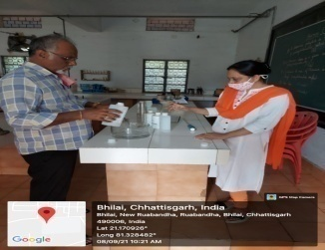



**St. Thomas College, Bhilai**

**P. G Department of Chemistry**

**Activity Report-2021-22**

**Day & Date:** (Wednesday) 8 /09/2021

**Topic:** Sanitizer Preparation

**Activity:** Sanitizer Preparation

**Number of Beneficiaries:** - 100

|  |  |  |  |
| --- | --- | --- | --- |
| **List of Beneficiaries:** | | | |
| Sl.No. | Name of Staff | Sl.No. | Name of Staff |
| 1 | Dr. M.G.Roymon | 52 | Mrs. Tulika Harshit |
| 2 | Dr. Mariam Jacob | 53 | Fr. Dr. Joshi Varghese |
| 3 | Dr. James mathew | 54 | Dr. Arvind Kumar Sahu |
| 4 | Dr. Chanda Verma | 55 | Dr. Anubhuti Jha |
| 5 | Dr. Debjani Mukherjee | 56 | Dr. Suruchi Parkey |
| 6 | Dr. Shiny Mendonce | 57 | Ms. Jyoti Dewangan |
| 8 | Dr. Suja Varghese | 58 | Mr. Akash Tamrakar |
| 9 | Dr. Sheeja Varkey | 60 | Mr. Netra Ku. Gupta |
| 10 | Dr. Ujjwala Supe | 61 | Ms. Sulagna Ghosh Barman |
| 11 | Mrs. Ritu Biswas | 62 | Mr. Rojan Joy |
| 12 | Dr. Susan R.Abraham | 63 | Ms. Yashmin Hussain |
| 13 | Dr. Aparna Ghosh | 64 | Ms. Udayasri.S |
| 14 | Dr. Joyamma John | 65 | Ms. Sheenu Balyan |
| 15 | Dr. Santosh Kumar Miri | 66 | Ms. Kajal Arora |
| 17 | Dr. V.Shanthi | 68 | Ms. Mohini Sharma |
| 18 | Dr. Rincy Bijo Abraham | 69 | Ms. Neha Chourisa |
| 19 | Dr. Smita Suresh Daniel | 70 | Mr. Sonu Kumar Singh |
| 20 | Mr. Kailash Narayan Verma | 71 | Mr. Shyji Thomas |
| 21 | Dr. Jayashree Balasubramanian | 72 | Mrs.Rachel Joy |
| 22 | Ms. K.Manju | 73 | Mr. P.D. Kunjumone |
| 23 | Dr. Sheeja Thomas | 74 | Mrs. Sandhya Bobby |
| 24 | Mrs. Deepti Santosh | 75 | Mrs. Jiji Yogesh |
| 25 | Dr. Sonia Popli | 76 | Mrs. Geetha D.Raj |
| 26 | Dr. Shabnam Khan | 77 | Mr. Michael Fernandez |
| 27 | Dr. Reema Dewangan | 78 | Mr. Jaishankar Achari |
| 28 | Dr. Rupa Shrivastava | 79 | Mr. Anil Varghese |
| 29 | Dr. Surekha Jawade | 80 | Mr. K.T. Paulose |
| 30 | Mrs. Susan Ebison | 81 | Mr. Sunny George |
| 31 | Dr. Laxman Prasad | 82 | Mr. Pushkar Verma |
| 32 | Ms. Preeti Jain | 83 | Mr. P.M Rajan |
| 33 | Dr. Sujata Koley | 84 | Mrs. Mini John |
| 34 | Dr. Sunita Kshatriya | 85 | Mrs. Dolly B. John |
| 35 | Dr. Aditi Acharya | 86 | Ms. Omana Cherian |
| 36 | Dr. Shubha Diwan | 87 | Mr. Gang Dev Karmakar |
| 37 | Mr. Mahendra Kumar Ikhar | 88 | Mrs. Pramila Devi |
| 38 | Mrs. Neelam Pandey | 89 | Mrs. Surekha |
| 39 | Dr. Pratik Kumar Sharma | 90 | Mrs. Dulari |
| 40 | Mr. J.Maju | 91 | Mrs.Shakun Yadav |
| 41 | Mrs. Ekta Saxena | 92 | Mrs. Teejan |
| 42 | Mr. Chandan P.Dekate | 93 | Mr. Dinesh |
| 43 | Mr. Kanhaiya Kumar Pandey | 94 | Mr. Sudhakar |
| 44 | Mr. Santosh Yadav | 95 | Mrs. Prema |
| 45 | Dr. Sumita Singh | 96 | Mr. B.R Verma |
| 46 | Dr. Jyotsna Gadpayle | 97 | Mr. Cheru |
| 47 | Mr. Amit Ku. Tamrakar |  | **Part Time** |
| 48 | Dr. Neethu Raj P. | 98 | Mr. Amitabh Sharma |
| 49 | Dr. Ankita Deshmukh | 99 | Ms. Soumya Dwivedi |
| 50 | Dr. Neelam Gandhi | 100 | Mr. Dev Narayan Patel |
| 51 | Dr. Anupama Gangarde |



**St. Thomas College, Bhilai**

**Department Of Biotechnology And Microbiology**

**Activity Report-2021-22**

Day & Date: (Saturday) 15/09/2021

Topic: Awareness on organic farming for sustainable agriculture Collaborating Agency: Farm Labs, Pune

Activity: Awareness Program

Number of Beneficiaries: 137

A webinar was organized by The P.G. department of biotechnology and microbiology on “Awareness on organic farming for sustainable agriculture” to make students aware about different types of organic farming practices one can take up. They also learned about the future applicability of this practice. It was organized on 15.9.2021. Dr. Santosh Chavan, Director, Farm labs; Pune talked about organic farming and its applicability in detail. He also spoke about different methods and different practices that can be taken up by students in early phase of their life which can later on help in a better environment. This session was organised by Dr V. Shanthi, Assistant Professor and Head of the department, St. Thomas College, Bhilai. It was also carried out under the guidance of Dr. Ujjawala Supe. The number of beneficiaries attended were137 from all over India. The webinar was conducted by Shubha Diwan and vote of thanks was given by Ms. Ekta Saxena

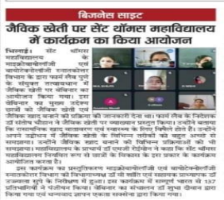



**St. Thomas College, Bhilai**

**Department Of Biotechnology And Microbiology**

**Activity Report-2021-22**

Day & Date: (Saturday) 15/09/2021

Topic: Awareness on organic farming for sustainable agriculture Collaborating Agency: Farm Labs, Pune

Activity: Awareness Program

Number of Beneficiaries: 137

|  |  |
| --- | --- |
| 1. [anubhutijhastc@gmail.com](mailto:anubhutijhastc@gmail.com) | Dr. Anubhuti Jha |
| 1. [sivasxc1992@gmail.com](mailto:sivasxc1992@gmail.com) | Dr S Siva Sankar |
| 1. [seemanag44@gmail.com](mailto:seemanag44@gmail.com) | Ms. SEEMA NAG |
| 1. [saadlecturer@yahoo.com](mailto:saadlecturer@yahoo.com) | Mr. Mohammed Sadequekhwaja |
| 1. [priyankathedesirable@gmail.com](mailto:priyankathedesirable@gmail.com) | Km Priyanka Singh |
| 1. [cuteriyamandal3101@gmail.com](mailto:cuteriyamandal3101@gmail.com) | Ms. Riya Mandal |
| 1. [nitinphirke@sgbau.ac.in](mailto:nitinphirke@sgbau.ac.in) | DR N.V.PHIRKE |
| 1. [pradhumnudainiya1999@gmail.com](mailto:pradhumnudainiya1999@gmail.com) | PradhumnUdainiya |
| 1. [thirupathimaloth9@gmail.com](mailto:thirupathimaloth9@gmail.com) | MALOTH THIRUPATHI |
| 1. [bhatiasaminder28@gmail.com](mailto:bhatiasaminder28@gmail.com) | Saminder Kaur |
| 1. [m.arpita.bhilai@gmail.com](mailto:m.arpita.bhilai@gmail.com) | Arpita Mukherjee |
| 1. [kausar.heena.704@gmail.com](mailto:kausar.heena.704@gmail.com) | Ms. HeenaKausar |
| 1. [anshuminj05041999@gmail.com](mailto:anshuminj05041999@gmail.com) | Ms. Anshu Mala Minj |
| 1. [mahapatra.sangitask@gmail.com](mailto:mahapatra.sangitask@gmail.com) | Sangita Mahapatra |
| 1. [khansabirimteyaz786@gmail.com](mailto:khansabirimteyaz786@gmail.com) | Mr. Shabir Khan |
| 1. [preetinagar1151@gmail.com](mailto:preetinagar1151@gmail.com) | Ms. PREETI NAGAR |
| 1. [singhmukta481@gmail.com](mailto:singhmukta481@gmail.com) | Mukta Singh |
| 1. [shikharmathurofficial@gmail.com](mailto:shikharmathurofficial@gmail.com) | ShikharMathur |
| 1. [jayapriya491998@gmail.com](mailto:jayapriya491998@gmail.com) | P. Jaya priya |
| 1. [prakashhshce@gmail.com](mailto:prakashhshce@gmail.com) | Mr .Prakash H S |
| 1. [smitaekka1304@gmail.com](mailto:smitaekka1304@gmail.com) | Ms. Smita Ekka |
| 1. [akshitvaishnavonlin@gmail.com](mailto:akshitvaishnavonlin@gmail.com) | Dr. Sharmilamaitra |
| 1. [asifanadeem1993@yahoo.com](mailto:asifanadeem1993@yahoo.com) | Asifa Nadeem Malik |
| 1. [sanjay9425537036@gmail.com](mailto:sanjay9425537036@gmail.com) | SANJAY RATHORE |
| 1. [annanya.rajput@rungtacolleges.com](mailto:annanya.rajput@rungtacolleges.com) | Ananya Rajput |
| 1. [mkashyapc@gmail.com](mailto:mkashyapc@gmail.com) | Ms. PunamKadhyap |
| 1. [yaminiprashanti@yahoo.in](mailto:yaminiprashanti@yahoo.in) | YAMINI PRASHANTI PATNAIK |
| 1. [manju.yarabati@gmail.com](mailto:manju.yarabati@gmail.com) | Dr. P. Manjula |
| 1. [ecpriya031990@gmail.com](mailto:ecpriya031990@gmail.com) | SIVA PRIYA |
| 1. [sakshibhadoriasb@gmail.com](mailto:sakshibhadoriasb@gmail.com) | SakshiBhadoria |
| 1. [anushree.pandey1995@gmail.com](mailto:anushree.pandey1995@gmail.com) | Anushree Pandey |
| 1. [shahanakalim@gmail.com](mailto:shahanakalim@gmail.com) | DrSyedaShahana |
| 1. [akhind2014@gmail.com](mailto:akhind2014@gmail.com) | Mr. Ashish Kumar Prajapati |
| 1. [jhilliprabha@gmail.com](mailto:jhilliprabha@gmail.com) | JhilliPrabhaPrusti |
| 1. [kajal15arora@gmail.com](mailto:kajal15arora@gmail.com) | Miss. Kajal Arora |
| 1. [harshitabunkar2001@gmail.con](mailto:harshitabunkar2001@gmail.con) | HarshitaBunkar |
| 1. [neelam912020@gmail.com](mailto:neelam912020@gmail.com) | Neelam |
| 1. [pragatiminj03@gmail.com](mailto:pragatiminj03@gmail.com) | Pragatiminj |
| 1. [nehaverma1791@gmail.com](mailto:nehaverma1791@gmail.com) | Ms. Neha Verma |
| 1. [deepa.biswas@kalingauniversity.ac.in](mailto:deepa.biswas@kalingauniversity.ac.in) | Dr. Deepa Biswas |
| 1. [rakhib@itmuniversity.org](mailto:rakhib@itmuniversity.org) | Dr. RakhiBajpai |
| 1. [rawatmohitkumar321@gmail.com](mailto:rawatmohitkumar321@gmail.com) | MOHIT KUMAR |
| 1. [sonaliputatunda16@gmail.com](mailto:sonaliputatunda16@gmail.com) | Ms. SONALI PUTATUNDA |
| 1. [saxenae95@gmail.com](mailto:saxenae95@gmail.com) | EktaSaxena |
| 1. [anushka222talukdar@gmail.com](mailto:anushka222talukdar@gmail.com) | Ms. AnushkaTalukdar |
| 1. [sonishrinum@gmail.com](mailto:sonishrinum@gmail.com) | ShreenamSoni |
| 1. [dipannitapcc.2020@gmail.com](mailto:dipannitapcc.2020@gmail.com) | DIPANNITA MAJUMDER |
| 1. [amishasen5167@gmail.com](mailto:amishasen5167@gmail.com) | Amisha Sen |
| 1. [drrautrd@gmail.com](mailto:drrautrd@gmail.com) | RANJANA DINKAR RAUT |
| 1. [nandita.pandey2610@gmail.com](mailto:nandita.pandey2610@gmail.com) | Ms. Nandita Pandey |
| 1. [richa.micro10@gmail.com](mailto:richa.micro10@gmail.com) | Dr. Richa Mishra |
| 1. [shanti_162@rediffmail.com](mailto:shanti_162@rediffmail.com) | Dr V Shanthi |
| 1. [vishalbargate81@gmail.com](mailto:vishalbargate81@gmail.com) | Vishal bargate |
| 1. [sadhanamgcgv@gmail.com](mailto:sadhanamgcgv@gmail.com) | DrSadhanaChaurasia |
| 1. [xarjunprakash.1998@gmail.com](mailto:xarjunprakash.1998@gmail.com) | Mr.Arjun Prakash |
| 1. [nikhilprakash2820@gmail.com](mailto:nikhilprakash2820@gmail.com) | Nikhil Prakash |
| 1. [aahaleemkhan@gmail.com](mailto:aahaleemkhan@gmail.com) | Dr Ahmed Abdul Haleem Khan |
| 1. [seemaverma72@gmail.com](mailto:seemaverma72@gmail.com) | Dr Seema Verma |
| 1. [shubhangini.a.kolakar@balbhawan.ac.in](mailto:shubhangini.a.kolakar@balbhawan.ac.in) | Shubhangini A Kolarkar |
| 1. [anjalibisen1709@gmail.com](mailto:anjalibisen1709@gmail.com) | Anjali Bisen |
| 1. [sushil.kalmegh@gmail.com](mailto:sushil.kalmegh@gmail.com) | Dr. SushilkumarRameshpantKalmegh |
| 1. [vermamanju399@gmail.com](mailto:vermamanju399@gmail.com) | manju |
| 1. [samtachemistry@gmail.com](mailto:samtachemistry@gmail.com) | Dr.Samta Deshpande |
| 1. [dumpajyotish6@gmail.com](mailto:dumpajyotish6@gmail.com) | JyotishDumpa |
| 1. [vishwajeets853@gmail.com](mailto:vishwajeets853@gmail.com) | MrVishwajeet Singh |
| 1. [stcaparna19@gmail.com](mailto:stcaparna19@gmail.com) | Dr. Aparna Ghosh |
| 1. [deepankarmondal65@gmail.com](mailto:deepankarmondal65@gmail.com) | DeepankarMondal |
| 1. [rahulbadgha1994@gmail.com](mailto:rahulbadgha1994@gmail.com) | Mr. Rahul G Badgha |
| 1. [papan.ec11@gmail.com](mailto:papan.ec11@gmail.com) | BHASKAR ROY |
| 1. [ganeshkhelware@gmail.com](mailto:ganeshkhelware@gmail.com) | Ganesh khelware |
| 1. [pervez.zoya12@gmail.com](mailto:pervez.zoya12@gmail.com) | Zoya Pervez |
| 1. [aditisrivastava11@gmail.com](mailto:aditisrivastava11@gmail.com) | Ms. Aditi Srivastava |
| 1. [vasu99sahu@gmail.com](mailto:vasu99sahu@gmail.com) | VASUNDHARA SAHU |
| 1. [pallavisingh.prsu@gmail.com](mailto:pallavisingh.prsu@gmail.com) | Ms. PALLAVI SINGH |
| 1. [singhjiya216@gmail.com](mailto:singhjiya216@gmail.com) | Jiyasingh |
| 1. [drneetusinghmaths@gmail.com](mailto:drneetusinghmaths@gmail.com) | DrNeetu Singh |
| 1. [lakeshwarisahu1998@gmail.com](mailto:lakeshwarisahu1998@gmail.com) | Lakeshwarisahu |
| 1. [trilokdev111@gmail.com](mailto:trilokdev111@gmail.com) | Dr. Trilok Kumar |
| 1. [sanjanasolomon4268@gmail.com](mailto:sanjanasolomon4268@gmail.com) | Ms. Sanjana Solomon |
| 1. [dl9273974@gmail.com](mailto:dl9273974@gmail.com) | DivyaGulabiLakra |
| 1. [sonalmishra2017@gmail.com](mailto:sonalmishra2017@gmail.com) | Dr.Sonal Mishra |
| 1. [navvinnair669@gmail.com](mailto:navvinnair669@gmail.com) | Mr N Naveen |
| 1. [pandeydurgeshkumar15@gmail.com](mailto:pandeydurgeshkumar15@gmail.com) | Mr.Durgesh Kumar Pandey |
| 1. [ayushee.sao@gmail.com](mailto:ayushee.sao@gmail.com) | Ayushee Sao |
| 1. [nikitamishra150@gmail.com](mailto:nikitamishra150@gmail.com) | Nikita Mishra |
| 1. [saroj6962@gmail.com](mailto:saroj6962@gmail.com) | SAROJ KUMAR MANDAL |
| 1. [shubha2315@gmail.com](mailto:shubha2315@gmail.com) | Dr. Shubha Diwan |
| 1. [bnayak.0112@gmail.com](mailto:bnayak.0112@gmail.com) | Mrs. Bhuneshwari Nayak |
| 1. [mary.khushbu@rungtacolleges.com](mailto:mary.khushbu@rungtacolleges.com) | Mary khushbuTirkey |
| 1. [97dnishi@gmail.com](mailto:97dnishi@gmail.com) | Ms D Nishi |
| 1. [rupashrivastava.rupa@gmail.com](mailto:rupashrivastava.rupa@gmail.com) | Dr. Rupashrivastava |
| 1. [nidhidongre25@gmail.com](mailto:nidhidongre25@gmail.com) | Ms. |
| 1. [pandeyankit.12348@gmail.com](mailto:pandeyankit.12348@gmail.com) | Mr. Rajesh Pandey |
| 1. [vivekgangathakur@gmail.com](mailto:vivekgangathakur@gmail.com) | Vivek thakur |
| 1. [vikaskusinha2781@gmail.com](mailto:vikaskusinha2781@gmail.com) | Vikas Kumar Sinha |
| 1. [rexietjeyasheeba@gmail.com](mailto:rexietjeyasheeba@gmail.com) | Mrs.M.REXIE T. JEYA SHEEBA |
| 1. [ash.siddiqui9@gmail.com](mailto:ash.siddiqui9@gmail.com) | Ms. Arshi Siddiqui |
| 1. [aksbotany@gmail.com](mailto:aksbotany@gmail.com) | DrAwadhesh Kumar Shrivastava |
| 1. [dewangandolly501@gmail.com](mailto:dewangandolly501@gmail.com) | DOLLY DEWANGAN |
| 1. [durgeshkeshar.prsu@gmail.com](mailto:durgeshkeshar.prsu@gmail.com) | DURGESH KUMAR KESHAR |
| 1. [kp6608@gmail.com](mailto:kp6608@gmail.com) | KANHAIYA KUMAR PANDEY |
| 1. [bioarpan@gmail.com](mailto:bioarpan@gmail.com) | Mr. Arpan Dey |
| 1. [mknarang10@gmail.com](mailto:mknarang10@gmail.com) | MahendraNarang |
| 1. [sushil.kalmegh@gmail.com](mailto:sushil.kalmegh@gmail.com) | Dr. SushilkumarRameshpantKalmegh |
| 1. [ujsupe@gmail.com](mailto:ujsupe@gmail.com) | Sunny George |
| 1. [ujsupe@gmail.com](mailto:ujsupe@gmail.com) | Ommna Cherian |
| 1. [ujsupe@gmail.com](mailto:ujsupe@gmail.com) | K.T. Paulose |
| 1. [ujsupe@gmail.com](mailto:ujsupe@gmail.com) | Dolly John |
| 1. ruqaiyahbaramatiwala@gmail.com | RuqaiyyaBaramatiwala |
| 1. [Rashmimurmu55@gmail.com](mailto:Rashmimurmu55@gmail.com) | Rashmi Murmu |
| 1. [vishwaprakashr@gmail.com](mailto:vishwaprakashr@gmail.com) | Dr. Vishwaprakash Roy |
| 1. [tjlpimple12@gmail.com](mailto:tjlpimple12@gmail.com) | TejalMaheshappa Pimple |
| 1. [buttejeevesh9@gmail.com](mailto:buttejeevesh9@gmail.com) | jeevesh butte |
| 1. keshavpisda2000@gmail.com | Keshav Prasad Pisda |
| 1. [dl9273974@gmail.com](mailto:dl9273974@gmail.com) | DivyaGulabiLakra |
| 1. [nishigandhakhule1@gmail.com](mailto:nishigandhakhule1@gmail.com) | Nishigandhavasantkhule |
| 1. vaishnvikur1501@gmail.com | VaishnviDilipraoKurhade |
| 1. [sakshikthakare@gmail.com](mailto:sakshikthakare@gmail.com) | Sakshi Kiran Thakare |
| 1. ramdasraut@nirmalseedsindia.com | Dr. Ramdas V Raut |
| 1. [dongresharayu23@gmail.com](mailto:dongresharayu23@gmail.com) | Sharayushailendradongre |
| 1. yadavharshita1500@ gmail.com | Harshita Yadav |
| 1. Shreeyachandrakar106@gmail.com | ShreeyaChandrakar |
| 1. [pallaviborekar298@gmail.com](mailto:pallaviborekar298@gmail.com) | Pallavi Satish Borekar |
| 1. [shreyashitayade03@gmail.com](mailto:shreyashitayade03@gmail.com) | SHREYASHI RAGHUNATH TAYADE |
| 1. [kalpanasahu63@gmail.com](mailto:kalpanasahu63@gmail.com) | Dr. Kaushalya Sahu |
| 1. Babitakaushik200198@gmail.com | BabitaKaushik |
| 1. [harsh75gupta15@gmail.com](mailto:harsh75gupta15@gmail.com) | Nisha gupta |
| 1. [preetbhavineemishra@gmail.com](mailto:preetbhavineemishra@gmail.com) | PreetbhavineeMishra |
| 1. [sanjivani.naik99@gmail.com](mailto:sanjivani.naik99@gmail.com) | sanjivaninaik |
| 1. [Kauqub@gmail.com](mailto:Kauqub@gmail.com) | KauqubFatima |
| 1. [manshichauhan.93@gmail.com](mailto:manshichauhan.93@gmail.com) | Manashi Chouhan |
| 1. stcujwala@gmail.com | Ujwala Supe |
| 1. vshanti@gmail.com | V.shanti |
| 1. shubha@gmail.com | Shubha Diwan |
| 1. jayshreestc@gmail.com | Jaysree Balasubramaniun |
| 1. Joymma @gmail.com | Joyma |
| 1. Joythibakshi2gmail.com | Jyoti Bakshi |



**St. Thomas College, Bhilai**

**PG Department Of Commerce**

**Activity Report-2021-22**

**Day & Date:** (Saturday) 18/09/2021

**Topic:** A Webinar on Entrepreneurship Skills

**Activity:** A Webinar

**Number of Beneficiaries:** 85

Under the aegis of Commzenith of PG department of commerce in collaboration with IBS (ICFA) Business School organized student development programme on the topic “Entrepreneurship Skills for Startups “on 18th September 2021. Prof. Surjyabrat Buragohain Queensland University of Technology Australia was the resource person on the occasion.

Along with the theoretical education, this program was organized for the overall development of students so that entrepreneurship knowledge could be developed in the students. Ms. Jayshree Roy an Alumni of St. Thomas Colege deparmrnt of commerce also shared her experiences with the students and urged students to come forward and face the competitive world.

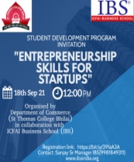



**St. Thomas College, Bhilai**

**PG Department Of Commerce**

**Activity Report-2021-22**

**Day & Date:** (Saturday) 18/09/2021

**Topic:** A Webinar on Entrepreneurship Skills

**Activity:** A Webinar

**Number of Beneficiaries:** 85

|  |  |  |  |
| --- | --- | --- | --- |
| S. No | Names of Students | S. No | Names of Students |
| 1. | Tarun rathore | 28 | Harshit Jain |
| 2 | Nitish Kumar | 29 | Indrajeet sahu |
| 3 | Harsh Arora | 30 | Jay Kumar Kande |
| 4 | Meenakshi | 31 | Jyoti Ghosh |
| 5 | Vishak Kumar | 32 | Karan Khalkho. |
| 6 | Pallavi Yadav | 33 | Komal Dhanwani |
| 7 | Vidya Dewangan | 34 | Lekha Thakur |
| 8 | Ashutosh Gupta | 35 | Madhu Kumari |
| 9 | Sakshi | 36 | Mansi Nishad |
| 10 | Dhanlaxmi Painkra | 37 | Md. Atif Khan |
| 11 | Rachit Yogi | 38 | Megha Sahu |
| 12 | Kunal Khalkho | 39 | Muskan Chopda |
| 13 | Divy Singh Parthar | 40 | N.V.S. Sushmita |
| 14 | Dumesh Kumar Sahu | 41 | Neeraj Suprim |
| 15 | Ekta Jobanputtra | 42 | Nitesh Bhoi |
| 16 | Faizaan Hussain | 43 | Harshit Jain |
| 17 | Fardeen Hussain | 45 | Indrajeet sahu |
| 18 | Farough Aukaf Khan | 46 | Anamika Mandal |
| 19 | Firdaush Anjum | 47 | Anil Sahu |
| 20 | Garima Chandra | 48 | Anjali Jaiswal |
| 21 | Gaurav Baghel | 49 | Anshika Vishwakarma |
| 22 | Gaurav Chandrakar | 50 | Anamika Mandal |
| 23 | Gavesh Kumar Sahu | 51 | Ketan Thakur |
| 24 | Ghreetika Sidar | 52 | Lakshya Nirmal |
| 25 | Gibbs Pramod | 53 | M Anuradha |
| 26 | Girish Kumar Paraste | 54 | Manoj Singh |
| 27 | Divy Singh Parthar | 55 | Ketan Thakur |

|  |  |  |  |
| --- | --- | --- | --- |
| S. No | Names of Students | S. No | Names of Students |
| 56 | Ruchi Lal | 83 | Neha Gandharva |
| 57 | S. Kusum | 84 | Nisha Jambhulkar |
| 58 | Sakshi | 85 | Palak Lilhare |
| 59 | Sambodhi Wahane |  |  |
| 60 | Sana Parveen |  |  |
| 61 | Sanchaita Bhattacharjee |  |  |
| 62 | Susmita Gupta |  |  |
| 63 | Thoufeeq Ahmad |  |  |
| 64 | Vanshika Jaiswal |  |  |
| 65 | Vedant Tiwari |  |  |
| 66 | Vikram Biswas |  |  |
| 67 | Vivek Shah |  |  |
| 68 | Yogita Verma |  |  |
| 69 | Yukta Gabel |  |  |
| 70 | Prabhat Kumar Bhagat |  |  |
| 71 | Pushpak Kundley |  |  |
| 72 | A Ruchi |  |  |
| 73 | Abhilash Mahto |  |  |
| 74 | Adarsh Nishad |  |  |
| 75 | Akanksha Nareti |  |  |
| 76 | Akhil C Thomas |  |  |
| 77 | Alok Gupta |  |  |
| 78 | Amitesh Chandrakar |  |  |
| 79 | Shubham Sonkar |  |  |
| 80 | Varidhi Pandey |  |  |
| 81 | Vishal Sharma |  |  |
| 82 | Mukesh Nayak |  |  |



**St. Thomas College, Bhilai**

**P.G. department of Microbiology and Biotechnology**

**Activity Report-2021-22**

**Day & Date:** (Thursday) 08/11/2021

**Topic:** Skill Development Program

**Activity: Skill Development Program –Mushrooms from Lab to Stall**

**Number of Beneficiaries:** 20

A skill development program was organized under the aegis of GENESIS by P.G. department of Microbiology and Biotechnology on 08.11.2021. It helped in educating the importance of laboratory practices in mushroom cultivation. The session was titled as “Mushrooms from lab to stall”. Total 20 students participated in this skill development program which was intended to teach students on how to process the substrate for mushroom cultivation and the conditions to maximize the yield so that they can take up this skill to start full-fledged mushroom cultivation and help in reaching the stalls for consumers

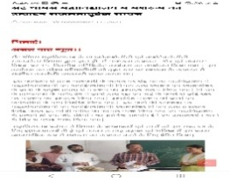



**St. Thomas College, Bhilai**

**P.G. department of Microbiology and Biotechnology**

**Activity Report-2021-22**

**Day & Date:** (Thursday) 08/11/2021

**Topic:** Skill Development Program

**Activity: Skill Development Program –Mushrooms from Lab to Stall**

**Number of Beneficiaries:** 20

|  |  |
| --- | --- |
| 1. vasudhasingh964@gmail.com | Vasudha Singh |
| 1. cuteriyamandal3101@gmail.com | Riya Mandal |
| 1. kathasanyal@gmail.com | Katha sanyal |
| 1. anushka222talukdar@gmail.com | AnushkaTalukdar |
| 1. [vasu99sahu@gmail.com](mailto:vasu99sahu@gmail.com) | vasundharasahu |
| 1. hariramsahu16@gmail.com | Dolly Sahu |
| 1. dewanganshaivi64@gmail.com | ShaiviDewangan |
| 1. nehaverma1791@gmail.com | Neha Verma |
| 1. anjalibisen1709@gmail.com | Anjali Bisen |
| 1. [saxenae95@gmail.com](mailto:saxenae95@gmail.com) | EktaSaxena |
| 1. sullubarman12@gmail.com | Sulagna Ghosh Barman |
| 1. divyasen579@gmail.com | Divya Sen |
| 1. sanjanasolomon4268@gmail.com | Sanjana Solomon |
| 1. vishalvargate81@gmail.com | Vishal Bargate |
| 1. [vaidehisarda4@gmail.com](mailto:vaidehisarda4@gmail.com) | Kiran |
| 1. mikety1995@gmail.com | Monika uikey |
| 1. [singhta481@gmail.com](mailto:singhta481@gmail.com) | Vasudhasingh |
| 1. [shikharmathurofficial@gmail.com](mailto:shikharmathurofficial@gmail.com) | ShikharMathur |
| 1. [jaydange491998@gmail.com](mailto:jaydange491998@gmail.com) | Akash dange |
| 1. himand@gmail.com | Sachin Tiwari |



**St. Thomas College, Bhilai**

**P.G. Department of Microbiology & Biotechnology**

**Activity Report-2021-22**

**Day & Date:** (Tuesday) 09/11/2021

**Topic:** Workshop

**Activity:** Workshop on Intellectual Property Rights: Patents & Design Process

**Number of Beneficiaries:** 38

A workshop was organized by P.G. Department of Microbiology & Biotechnology in collaboration with Rajiv Gandhi National Institute of Intellectual Property Management, Nagpur. This session was attended by faculty members and students of all the streams. The topic of the session was “**Intellectual Property Rights: Patents & Design Process**”. The Resource person; Dr. Pooja Maulikar elaborated on the process of filing a patent. She also acquainted the participants with various intellectual property rights, rules and protocols for trademarks GI tags and copyrights.

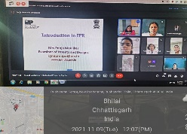



**St. Thomas College, Bhilai**

**P.G. Department of Microbiology & Biotechnology**

**Activity Report-2021-22**

**Day & Date:** (Tuesday) 09/11/2021

**Topic:** Workshop

**Activity:** Workshop on Intellectual Property Rights: Patents & Design Process

**Number of Beneficiaries:** 38

|  |  |
| --- | --- |
| 1. priya.diwed07@gmail.com | PriyaDiwedi |
| 1. nehagoel.agrawal@gmail.com | Ms. Neha Goel |
| 1. msmishra002@gmail.com | Dr Mohit Mishra |
| 1. Vyaskrishna14@gmail.com | Mr. Krishna Murti Vyas |
| 1. amogh.mitra09@gmail.com | AmoghMitra |
| 1. nikitataddy12@gmail.com | Taddy Nikita |
| 1. aditya.kate666@gmail.com | Aditya Dhananjay Kate |
| 1. raovishal040@gmail.com | VISHAL KUMAR RAO |
| 1. akankshanandani92@gmail.com | Ms. AkanshaNandani |
| 1. tejpalsinghparmar27@gmail.com | Dr.Tejpal Singh Parmar |
| 1. vikki050193@gmail.com | Mr.VIGNESH KARTHIKEYAN |
| 1. shahaadil10@gmail.com | Mr AADIL FAROOQ SHAH |
| 1. seema.belorkar@gmail.com | Seema Belorkar |
| 1. shivlalbanjarebuddhist@gmail.com | Mr.SHIVLAL BANJARE |
| 1. rathia.pradeep2@gmail.com | Mr.Pradeep Kumar Rathia |
| 1. rupomtimung123@gmail.com | Mr.RUPOM TIMUNG |
| 1. dipanjan2010@gmail.com | Dr. Dipanjan Ray |
| 1. urmitachandra92@gmail.com | Mrs. Urmitachandra Chowdhury |
| 1. arindambhunia174@gmail.com | Mr. ARINDAM BHUNIA |
| 1. maitysuvendu1992@gmail.com | Mr. SUVENDU MAITY |
| 1. indra.bed.2004@gmail.con | Mr. Indrojitsaha |
| 1. arpita10c@gmail.com | Dr. Arpita Chatterjee |
| 1. mariam29yusra@gmail.com | Yusra mariam |
| 1. Fzaya2004@gmail.com | Dr. FaizaTawatiAbdulnaserTawatiBarwjiaya |
| 1. rakesh.sahu13@gmail.com | Dr. Rakesh Kumar Sahu |
| 1. james.wins82@gmail.com | Mr JOECECIL R |
| 1. james.wins82@gmail.com | Mr JOECECIL R |
| 1. rvgaikwad92@gmail.com | Mr. Ravindra Ganpati Gaikwad |
| 1. alkabanchhor91@gmail.com | Alka Banchhor |
| 1. bhawanapandey15@gmail.com | Dr Bhawana Pandey |
| 1. bmbmm35@gmail.com | Dr. Barna Pal Mazumdar |
| 1. divyapaikara@gmail.com | DIVYA PAIKARA |
| 1. madhulika.shrivastava59@gmail.com | DR.MADHULIKA SHRIVASTAVA |
| 1. sanjoy_bordolui@rediffmail.com | Dr. Sanjoy Kumar Bordolui |
| 1. swapanb1@rediffmail.com | DR SWAPAN MANDAL |
| 1. Hetalkumar.doshi1974@gmail.com | Hetalkumar P. Doshi |
| 1. rajibratankashyap100@gmail.com | RajibRatanKashyap |
| 1. dipanshu.sls@gmail.com | DR. DIPANSHU KUMAR VISHWAS |



**St. Thomas College, Bhilai**

**Committee of promotion to Research Activities**

**Activity Report-2021-22**

**Day & Date:** 26/11/ 2021Friday

**Topic:** Impact of Various credentials on research activities

**Activity:** A Guest lecture

**Number of Beneficiaries:** 57STC students

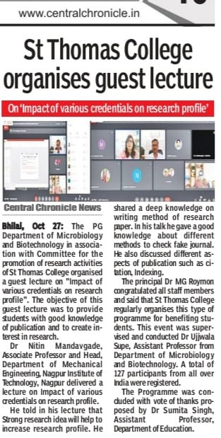For the publication of resrch paper in indexed journal, Dr. Nitin Mandavgade was given a lecture in St. Thomas College, Bhilai.Dr. Nitin told the participants to recognize the fake journal site and published the papers in UGC care listed Journals. Dr. Nitin also updated the students to registered in UGC – CARE website for check the journals. He encouraged the students to register in research gate and research scholars.

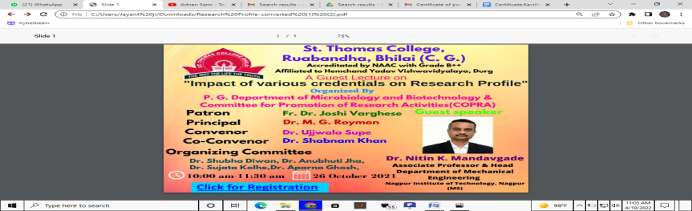



**St. Thomas College, Bhilai**

**Committee of promotion to Research Activity**

**Activity Report-2021-22**

**Day & Date:** 26/11/ 2021Friday

**Topic:** Impact of Various credentials on research activities

**Activity:** A Guest lecture

**Number of Beneficiaries:** 57STC students

|  |  |  |
| --- | --- | --- |
| Email Address | Name of Participant (Mr./Ms./Dr.)TO BE PRINTED ON THE CERTIFICATE | College/Organization (write full name) |
| anubhutijhastc@gmail.com | Dr. Anubhuti Jha | ST. THOMAS COLLEGE,BHILAI |
| cuteriyamandal3101@gmail.com | Ms. Riya Mandal | ST. THOMAS COLLEGE,BHILAI |
| bhatiasaminder28@gmail.com | Saminder Kaur | ST. THOMAS COLLEGE,BHILAI |
| shikharmathurofficial@gmail.com | Shikhar Mathur | ST. THOMAS COLLEGE,BHILAI |
| smitaekka1304@gmail.com | Ms. Smita Ekka | ST. THOMAS COLLEGE,BHILAI |
| yaminiprashanti@yahoo.in | YAMINI PRASHANTI PATNAIK | ST. THOMAS COLLEGE,BHILAI |
| kajal15arora@gmail.com | Miss. Kajal Arora | ST. THOMAS COLLEGE,BHILAI |
| harshitabunkar2001@gmail.con | Harshita Bunkar | ST. THOMAS COLLEGE,BHILAI |
| neelam912020@gmail.com | Neelam | ST. THOMAS COLLEGE,BHILAI |
| pragatiminj03@gmail.com | Pragati minj | ST. THOMAS COLLEGE,BHILAI |
| saxenae95@gmail.com | Ekta Saxena | st. thomas college,bhilai |
| anushka222talukdar@gmail.com | Ms. Anushka Talukdar | st. thomas college,bhilai |
| amishasen5167@gmail.com | Amisha Sen | st. thomas college,bhilai |
| shanti_162@rediffmail.com | Dr V Shanthi | st. thomas college,bhilai |
| stcsujavarghese@gmail.com | Dr. Suja Varghese | st. thomas college,bhilai |
| vishalbargate81@gmail.com | Vishal bargate | ST. THOMAS COLLEGE,BHILAI |
| ujsupe@gmail.com | DR. UJJWALA SUPE | ST. THOMAS COLLEGE,BHILAI |
| mansisuktel1903@gmail.com | Mansi Suktel | ST. THOMAS COLLEGE,BHILAI |
| anjalibisen1709@gmail.com | Anjali Bisen | ST. THOMAS COLLEGE,BHILAI |
| stcaparna19@gmail.com | Dr. Aparna Ghosh | ST. THOMAS COLLEGE,BHILAI |
| pervez.zoya12@gmail.com | Zoya Pervez | St. Thomas college,bhilai |
| vasu99sahu@gmail.com | VASUNDHARA SAHU | St. Thomas college,bhilai |
| lakeshwarisahu1998@gmail.com | Lakeshwari sahu | St. Thomas college,bhilai |
| sanjanasolomon4268@gmail.com | Ms. Sanjana Solomon | St. Thomas college,bhilai |
| dl9273974@gmail.com | Divya Gulabi Lakra | St. Thomas college,bhilai |
| navvinnair669@gmail.com | Mr N Naveen | St. Thomas college,bhilai |
| nikitamishra150@gmail.com | Nikita Mishra | St. Thomas college,bhilai |
| shubha2315@gmail.com | Dr. Shubha Diwan | St. Thomas college,bhilai |
| 97dnishi@gmail.com | Ms D Nishi | St. Thomas college,bhilai |
| rupashrivastava.rupa@gmail.com | Dr. Rupa shrivastava | St. Thomas college,bhilai |
| dewangandolly501@gmail.com | DOLLY DEWANGAN | ST. THOMAS COLLEGE,BHILAI |
| kp6608@gmail.com | KANHAIYA KUMAR PANDEY | ST. THOMAS COLLEGE,BHILAI |
| ujsupe@gmail.com | Sunny George | ST. THOMAS COLLEGE,BHILAI |
| ujsupe@gmail.com | Ommna Cherian | ST. THOMAS COLLEGE,BHILAI |
| ujsupe@gmail.com | K.T. Paulose | st. thomas college,bhilai |
| ujsupe@gmail.com | Dolly John | st. thomas college,bhilai |



**St. Thomas College, Bhilai**

**Department of Management Studies**

**Activity Report-2021-22**

**Day & Date:** (Friday) 12/11/2021(Wednesday) 24 /11/2021

**Activity:** Certificate Program on Professional Business Skills In Collaboration with Kalinga University.

**Topic:** Certificate Program

**Number of Beneficiaries:** 60

Department of Management Studies, St. Thomas College Bhilai in collaboration with Kalinga University Raipur organized inaugural session of the second edition of Certificate Program on “Professional Business Skills” from 12th November to 24th November 2021. In this Certificate Program participants learned the changing patterns of corporate working culture and accordingly they have to develop professional skills.





**St. Thomas College, Bhilai**

**Department of Management Studies**

**Activity Report-2021-22**

**Day & Date:** (Friday) 12/11/2021(Wednesday) 24 /11/2021

**Activity:** Certificate Program on Professional Business Skills In Collaboration with Kalinga University.

**Topic:** Certificate Program

**Number of Beneficiaries:** 60

|  |  |  |  |  |  |
| --- | --- | --- | --- | --- | --- |
| **S.No** | **Student Name** | **Class** | **S.No** | **Student Name** | **Class** |
|  | Aarti Bhagat | 5th Sem | 31. | Priya Diwan | 3rd Sem |
|  | Adarsh Maloo | 1st Sem | 32. | Ritika Yadav | 3rd Sem |
|  | Akash K Poddar | 1st Sem | 33. | Ritu Agrawal | 1st Sem |
|  | Akshat Bhalla | 1st Sem | 34. | Ritu Kumari | 3rd Sem |
|  | Akshita Tiwarkar | 3rd Sem | 35. | Rupsi | 5th Sem |
|  | Ankit Agrawal | 3rd Sem | 36. | Sanjana Chhatija | 5th Sem |
|  | Arpit Kumar Paik | 5th Sem | 37. | Siddhant Dixit | 1st Sem |
|  | Aryan K Vishwakarma | 1st Sem | 38. | Tarun Chopda | 1st Sem |
|  | Atul Jaswani | 5th Sem | 39. | Tushar Sarin | 3rd Sem |
|  | Ayur Rao Mahajan | 3rd Sem | 40. | Vineet Gupta | 1st Sem |
|  | Bhumika Rathore | 1st Sem | 41. | Vishal Uikey | 3rd Sem |
|  | Bhupendra Sahu | 3rd Sem | 42. | Vishvajit Shah | 1st Sem |
|  | Chanchala | 3rd Sem | 43. | Vivek Shukla | 3rd Sem |
|  | Chanda Harpal | 3rd Sem | 44. | Yash Laheja | 5th Sem |
|  | Chetan Kumar | 3rd Sem | 45. | Yashasvi Dubey | 3rd Sem |
|  | Gaurav Lodha | 1st Sem | 46. | Yashwant Reddy | 3rd Sem |
|  | Harsh Shukla | 1st Sem | 47. | Vishal | 3rd Sem |
|  | Harshita Rai | 1st Sem | 48. | Varsha Dhruw | 5th Sem |
|  | Himanshu Verma | 3rd Sem | 49. | Sunil Pradhan | 5th Sem |
|  | Isha Mahima | 3rd Sem | 50. | Simran Kaur Somal | 3rd Sem |
|  | Jeetendra Sahu | 3rd Sem | 51. | Shilpi Achari | 1st Sem |
|  | Jessica Johnson | 3rd Sem | 52. | Sanjana Sachdev | 3rd Sem |
|  | Lija Gaud | 3rd Sem | 53. | Rashmita | 3rd Sem |
|  | Lucky Kumar Singh | 3rd Sem | 54. | Radha | 3rd Sem |
|  | Marry Monalisa | 1st Sem | 55. | R. S. Aswathi | 1st Sem |
|  | Mohammad Abeer | 1st Sem | 56. | Nidhi | 1st Sem |
|  | Mummun Kshyap | 5th Sem | 57. | Mouli Dani | 5th Sem |
|  | Neeraj Kumar | 1st Sem | 58. | Md. Gulam Asharaf | 1st Sem |
|  | Neha Jacob | 1st Sem | 59. | Koena | 3rd Sem |
|  | Pooja Gupta | 5th Sem | 60. | Aaditya Sahu | 5th Sem |



**St. Thomas College, Bhilai**

**PG Department of Economics**

**Activity Report-2021-22**

**Day & Date:** (Friday) 12/11/2021

**Topic:** Guest Lecture on Career Option in Economics

**Activity:** Guest Lecture

**Number of Beneficiaries:** 78

A Guest Lecture was organised by the Department on Career Option in Economics. The Guest speaker was Dr. Vinit Ku Sahu Assistant Professor, Govt. Kachna College Chhura, Gariaband. Chhattisgarh. It was a session which focussed on various options available for students of Economics. It was an interactive online session, many students enthusiastically attended the session and cleared their doubts regarding career options, 78 students of St. Thomas College were benefited.

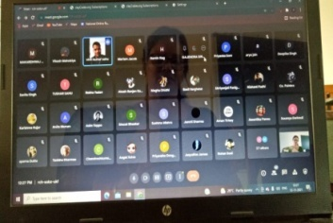



**St. Thomas College, Bhilai**

**PG Department of Economics**

**Activity Report-2021-22**

**Day & Date:** (Friday) 12/11/2021

**Topic:** Guest Lecture on Career Option in Economics

**Activity:** Guest Lecture

**Number of Beneficiaries:** 78

|  |  |  |  |  |  |
| --- | --- | --- | --- | --- | --- |
| **Sl. No** | **Name of the students** | **Stream** | **Sl. No** | **Name of the students** | **Stream** |
| 1 | Richa Mathew | MA Eco | 27 | Akanksha Rana | BA |
| 2 | Harshita | MA Eco | 28 | Amon Wilson | BA |
| 3 | Aparna Dutta | MA Eco | 29 | Angel Xalxo | BA |
| 4 | MeghaDhihi | MA Eco | 30 | Anmol Singh Thakur | BA |
| 5 | Anjali | MA Eco | 31 | Asim Toppo | BA |
| 6 | Deepika Singh | MA Eco | 32 | Chaitnyaku. Sahu | BA |
| 7 | Basil Varghese | MA Eco | 33 | Deepanjali Dhruv | BA |
| 8 | Padmini Patra | MA Eco | 34 | Disha K.S. | BA |
| 9 | AshwaryaBanchor | BA | 35 | Jahnavi Mishra | BA |
| 10 | Angel Angelika | BA | 36 | KashishKaria | BA |
| 11 | Ankushi Jain | BA | 37 | LeezaLowanshi | BA |
| 12 | Arya Jain | BA | 38 | Manisha ku. Enwati | BA |
| 13 | Chetna Shendey | BA | 39 | NeeleshPahuja | BA |
| 14 | Divya Singh | BA | 40 | Apurva Pandey | BCom |
| 15 | Harshita Jolhe | BA | 41 | Avinash Thakur | BCom |
| 16 | Jaqualine James | BA | 42 | Bhoomika Singh | BCom |
| 17 | Kashish Jain | BA | 43 | Diksha Samudra | BCom |
| 18 | Khileshku. Sahu | BA | 44 | Gaurav Kumar | BCom |
| 19 | MalineeMeccha | BA | 45 | Isha Gupta | BCom |
| 20 | Mo. Sameer Chouhan | BA | 46 | Jyoti Verma | BCom |
| 21 | Nishant Padhi | BA | 47 | K. Pawan Kuman | BCom |
| 22 | Rishabh Ramteke | BA | 48 | LikeshKorram. | BCom |
| 23 | Riya Rahate | BA | 49 | Mahima Bang | BCom |
| 24 | Rohan ku. Soni | BA | 50 | Mansi Sharma | BCom |
| 25 | Saleeha Khan | BA | 51 | Mehul Gupta | BCom |
| 26 | Satyam Ghritlahare | BA | 52 | MuskanSuna | BCom |
| 53 | Payal Das | BCom | 66 | Harshita Bunkar | BSc |
| 54 | PranshuSahu | BCom | 67 | Preeti Dalai | BSc |
| 55 | Pratyush Gupta | BCom | 68 | Shruti Verma | BCom |
| 56 | Dharam Khatwani | BCom | 69 | Shailja Dubey | BCom |
| 57 | Durgesh Ku Kothari | BCom | 70 | YoshitaSahu | BBA |
| 58 | Gajendra Ogare | BCom | 71 | Ku. Minakshi Verma | BA Final |
| 59 | Goswami Jyoti Bharti | BCom | 72 | Mandeep Bhalla | BA Final |
| 60 | HaripriyaMandavi | BCom | 73 | Manisha Yadav | BA Final |
| 61 | Harsh Pandey | BCom | 74 | ManwatkarMahek Harsh Kumar | BA Final |
| 62 | Harshit Jain | BCom | 75 | Mohit Kumar Sahu | BA Final |
| 63 | Indrajeetsahu | BCom | 76 | Naveen Dhruv | BA Final |
| 64 | Jay Kumar Kande | BCom | 77 | Neelima Dhruv | BA Final |
| 65 | Jyoti Ghosh | BCom | 78 | Aarti Baigh | BSc |



**St. Thomas College, Bhilai**

**PG Department of chemistry**

**Activity Report-2021-22**

**Day & Date:** (Thursday)16 /12/2021

**Topic:** Awarenes Program

**Activity:** Awarenes Program on recycling of waste plastic product

**Number of Beneficiaries:** 40

The PG Department of chemistry was organized best out of waste for PG students. These programme aware the students to how we reuse of plastics bottles or waste materials. Student’s makes hanging pot from waste plastic bottles.

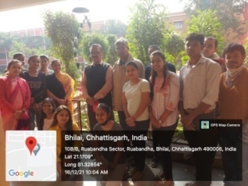



**St. Thomas College, Bhilai**

**PG Department of chemistry**

**Activity Report-2021-22**

**Day & Date:** (Thursday)16 /12/2021

**Topic:** Awarenes Program

**Activity:** Awarenes Program on recycling of waste plastic product

**Number of Beneficiaries:** 40

|  |  |  |  |
| --- | --- | --- | --- |
| 1. | Aakash | 21. | Akash Tiwari |
| 2. | Aanchal Kannoje | 22. | Annu Chandra |
| 3. | Chanchal Singh | 23. | Anshu |
| 4. | Dipti | 24. | Ashu Chandrakar |
| 5. | Gaurav Gautam | 25. | Chandrakiran Dilliwar |
| 6. | Harshita Yadav | 26. | Deeksha Sahu |
| 7. | Jesna Saji | 27. | Dipti Sahu |
| 8. | Khileshwari | 28. | Gayatri Chandrakr |
| 9. | Komal Sahu | 29. | Leena Sahu |
| 10. | Monica Dalal | 30. | Lumendra Kumar Pousarya |
| 11. | Purnima | 31. | Mayuri Singh |
| 12. | Radhika Kashyap | 32. | Nayan Rajput |
| 13. | Rajani Binod | 33. | Neetu Tirkey |
| 14. | Rupal Verma | 34. | Pooja Rao |
| 15. | Sakshi Yadav | 35. | Pratik Rajput |
| 16. | Samarth Gupta | 36. | Prerna Gautam |
| 17. | Shailja | 37. | Priyanka Mudliyar |
| 18. | Sakshi Kumari Mishra | 38. | Renuka Kumari |
| 19. | Tarun Koshale | 39. | Yashmi Sahu |
| 20. | Yonesh Banpela | 40. | Yashwant Kumar |



**St. Thomas College, Bhilai**

**PG Department Of Commerce**

**Activity Report-2021-22**

**Day & Date:** (Friday) 17/12/2021

**Topic:** Webinar in collaboration with Metropolitan Stock Exchange

**Activity:** Webinar

**Number of Beneficiaries:** 214



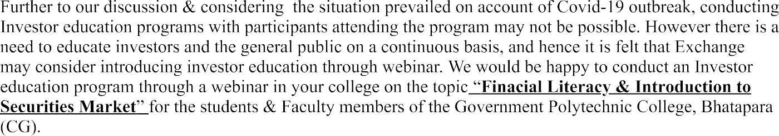



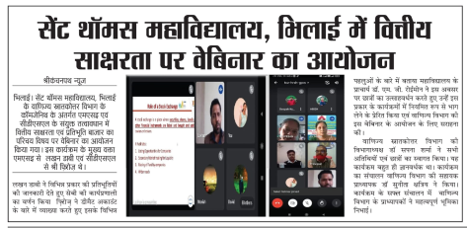



**St. Thomas College, Bhilai**

**PG Department Of Commerce**

**Activity Report-2021-22**

**Day & Date:** (Friday) 17/12/2021

**Topic:** Webinar in collaboration with Metropolitan Stock Exchange

**Activity:** Webinar

**Number of Beneficiaries:** 214

|  |  |  |  |  |  |  |  |  |
| --- | --- | --- | --- | --- | --- | --- | --- | --- |
| S.NO | NAME | CLASS | S.NO | NAME | CLASS | S.NO | NAME | CLASS |
| 1 | **Vivek Kumar Dansena** | B.Com III | 76 | DUSHYANT KR SAHU | M.Com III Sem | 151 | **Komal Dhanwani** | B.Com III |
| 2 | **Yogendra Kumar Kamde** | B.Com III | 77 | ESSITA BANERJEE | M.Com III Sem | 152 | **Lekha Thakur** | B.Com III |
| 3 | **Yogita** | B.Com III | 78 | INDU DAKSH | M.Com III Sem | 153 | **Madhu Kumari** | B.Com III |
| 4 | **Dipesh Soni** | B.Com III | 79 | KAMESH PATEL | M.Com III Sem | 154 | **Mansi Nishad** | B.Com III |
| 5 | **Jibin Johnson** | B.Com III | 80 | KAMESH SAHU | M.Com III Sem | 155 | **Md. Atif Khan** | B.Com III |
| 6 | **Aadil Ahmed** | B.Com III | 81 | KHUSHBOO SAHU | M.Com III Sem | 156 | **Megha Sahu** | B.Com III |
| 7 | **Abhishek Dhurwey** | B.Com III | 82 | KUNAL KHALKHO | M.Com III Sem | 157 | **Muskan Chopda** | B.Com III |
| 8 | **Aditya Singh** | B.Com III | 83 | KUNIKA SINHA | M.Com III Sem | 158 | **N.V.S. Sushmita** | B.Com III |
| 9 | **Akash Chandra** | B.Com III | 84 | LOKESH  SAHU | M.Com III Sem | 159 | **Neeraj Suprim** | B.Com III |
| 11 | **Aman Singh** | B.Com III | 86 | Abhishek Nagpure | B. Com II | 161 | **P B. Rohith** | B.Com III |
| 12 | **Anamika Mandal** | B.Com III | 87 | Abhishek Patro | B. Com II | 162 | **Pallavi Sahu** | B.Com III |
| 13 | **Anil Sahu** | B.Com III | 88 | Abhishek Singh | B. Com II | 163 | **Pooja Soni** | B.Com III |
| 14 | **Anjali Jaiswal** | B.Com III | 89 | Adarsh Kumar | B. Com II | 164 | **Arreb Ahmed** | B.Com III |
| 15 | **Anshika Vishwakarma** | B.Com III | 90 | Adesh Kumar Kurre | B. Com II | 165 | **Davis Joji Mathew** | B.Com III |
| 16 | **Ayushi Chelshi Bhagat** | B.Com III | 91 | Adhira Dhanush | B. Com II | 166 | **Prakhar Kumar Verma** | B.Com III |
| 17 | **Bhavana** | B.Com III | 92 | Aditi Mishra | B. Com II | 167 | **Saurabh Tripathi** | B.Com III |
| 18 | **Chhatrapal Chandra** | B.Com III | 93 | Aditi Sahu | B. Com II | 168 | **Yash Tandon** | B.Com III |
| 19 | **Daksh Keshwani** | B.Com III | 94 | Aditi Shriwas | B. Com II | 169 | **Pranjal Sahu** | B.Com III |
| 20 | **Deepak Verma** | B.Com III | 95 | Ishika Dang | B. Com II | 170 | **Palak Pashine** | B.Com III |
| 21 | **Divya Prakash Verma** | B.Com III | 96 | Ishika Naik | B. Com II | 171 | **Shubhranshu Tiwari** | B.Com III |
| 22 | **Ekta Sharma** | B.Com III | 97 | Ishika Pai | B. Com II | 172 | **Leena Sahu** | B.Com III |
| 23 | **Geetanjali Kharsan** | B.Com III | 98 | Jagrit Kumar Amela | B. Com II | 173 | **Nitish Kumar** | B.Com III |
| 24 | **Gurvinder Singh** | B.Com III | 99 | Jansan Mahilang | B. Com II | 174 | **Malkit Singh** | B.Com III |
| 25 | **Harpreet Singh Arora** | B.Com III | 100 | Jharna Verma | B. Com II | 175 | **Rachit Yogi** | B.Com III |
| 26 | **Harsh Verma** | B.Com III | 101 | Jheel Chaudhary | B. Com II | 176 | **Komal Dhanwani** | B.Com III |
| 27 | **Himani Chandrabel** | B.Com III | 102 | Jitesh Prasad | B. Com II | 177 | **Lekha Thakur** | B.Com III |
| 28 | **Janvi Raj** | B.Com III | 103 | Anshu Kumar Pandey | B. Com II | 178 | **Madhu Kumari** | B.Com III |
| 29 | **Jeevan C .George** | B.Com III | 104 | Bhowmick Shailly | B. Com II | 179 | **Mansi Nishad** | B.Com III |
| 30 | **K .Mamta** | B.Com III | 105 | Chhaya Soni | B. Com II | 180 | **Md. Atif Khan** | B.Com III |
| 31 | **Kawaljeet Kaur** | B.Com III | 106 | D. Bhavika | B. Com II | 181 | **Megha Sahu** | B.Com III |
| 32 | Numesh Kumar Sahu | B.Com II | 107 | Damini | B. Com II | 182 | **Muskan Chopda** | B.Com III |
| 33 | Ojashvi Deshmukh | B.Com II | 108 | Damini Dewangan | B. Com II | 183 | **N.V.S. Sushmita** | B.Com III |
| 34 | Palash Udapure | B.Com II | 109 | Dimple Thakur | B. Com II | 184 | **Neeraj Suprim** | B.Com III |
| 35 | Pallavi Kumari | B.Com II | 110 | Harsh Singh Parmar | B. Com II | 185 | **Nitesh Bhoi** | B.Com III |
| 36 | Pankaj Bhuarya | B.Com II | 111 | Himanshu Kaiwartya | B. Com II | 186 | **P B. Rohith** | B.Com III |
| 37 | Shubham Kumar Sahu | B.Com II | 112 | Janki | B. Com II | 187 | **Pallavi Sahu** | B.Com III |
| 38 | Shweta | B.Com II | 113 | Joel S Abraham | B. Com II | 188 | **Pooja Soni** | B.Com III |
| 39 | C. Vivek | B.Com II | 114 | K.A Surya | B. Com II | 189 | **Arreb Ahmed** | B.Com III |
| 40 | Chandan Dewangan | B.Com II | 115 | Kajal Uranw | B. Com II | 190 | **Davis Joji Mathew** | B.Com III |
| 41 | Chanpreet Kaur | B.Com II | 116 | Kanchan Soni | B. Com II | 191 | **Prakhar Kumar Verma** | B.Com III |
| 42 | Devanshi Chheda | B.Com II | 117 | Krishnakant Bhoi | B. Com II | 192 | **Saurabh Tripathi** | B.Com III |
| 43 | Devesh Singh Thakur | B.Com II | 118 | Kundan Korla | B. Com II | 193 | **Yash Tandon** | B.Com III |
| 44 | Devshree Deshmukh | B.Com II | 119 | Mallika Thakur | B. Com II | 194 | **Pranjal Sahu** | B.Com III |
| 45 | Dikesh Kumar Deshmukh | B.Com II | 120 | Mayank Kumar Pandey | B. Com II | 195 | **Tarun Kumas Rathore** | B.Com III |
| 46 | Diksha Soni | B.Com II | 121 | Mili Mathew | B. Com II | 196 | **Utkarsh Gupta** | B.Com III |
| 47 | Disha Das | B.Com II | 122 | Mini John | B. Com II | 197 | **Vaibhav Yadav** | B.Com III |
| 48 | Divy Singh Parthar | B.Com II | 123 | Mittal Ben | B. Com II | 198 | **Vibha Sahu** | B.Com III |
| 49 | Dumesh Kumar Sahu | B.Com II | 124 | N Sai Darsika | B. Com II | 199 | **Vivek Kumar Dansena** | B.Com III |
| 50 | Ekta Jobanputtra | B.Com II | 125 | Naresh Xalxo | B. Com II | 200 | **Yogendra Kumar Kamde** | B.Com III |
| 51 | Faizaan Hussain | B.Com II | 126 | Nayana Sone | B. Com II | 201 | **Yogita** | B.Com III |
| 52 | Fardeen Hussain | B.Com II | 127 | Neelesh Dwivedi | B. Com II | 202 | **Dipesh Soni** | B.Com III |
| 53 | Farough Aukaf Khan | B.Com II | 128 | Nisha | B. Com II | 203 | **Jibin Johnson** | B.Com III |
| 54 | Firdaush Anjum | B.Com II | 129 | Nisha Verma | B. Com II | 204 | **Aadil Ahmed** | B.Com III |
| 55 | Garima Chandra | B.Com II | 130 | Nishi Nair | B. Com II | 205 | **Ashish Kumar** | B.Com III |
| 56 | Gaurav Baghel | B.Com II | 131 | Nitin Gupta | B. Com II | 206 | **Avnit Bhatia** | B.Com III |
| 57 | Gaurav Chandrakar | B.Com II | 132 | Nitya Gupta | B. Com II | 207 | **Ayushi Mishra** | B.Com III |
| 58 | Ashish Kumar Sahu | M.Com I Sem | 133 | Numesh Kumar Sahu | B. Com II | 208 | **Bhupen Kumar Mallick** | B.Com III |
| 59 | Avinash Besra | M.Com I Sem | 134 | Ojashvi Deshmukh | B. Com II | 209 | **D Kaarthikeyan** | B.Com III |
| 60 | Barkha Kumari | M.Com I Sem | 135 | Palash Udapure | B. Com II | 210 | **Deepak Kumar Singh** | B.Com III |
| 61 | Jaya Netam | M.Com I Sem | 136 | Pallavi Kumari | B. Com II | 211 | **Diksha Bangare** | B.Com III |
| 62 | Jitendra Verma | M.Com I Sem | 137 | Pankaj Bhuarya | B. Com II | 212 | **Vidya Kumari** | B.Com III |
| 63 | Monika Mandloi | M.Com I Sem | 138 | Shubham Kumar Sahu | B. Com II | 213 | **Ashish Kumar** | B.Com III |
| 64 | Neelam Aditya | M.Com I Sem | 139 | Ekta Sharma | B. Com II | 214 | **Avnit Bhatia** | B.Com III |
| 65 | Neha Gandharva | M.Com I Sem | 140 | Geetanjali Kharsan | B. Com II |  |  |  |
| 66 | Nisha Jambhulkar | M.Com I Sem | 141 | Gurvinder Singh | B. Com II |  |  |  |
| 67 | Palak Lilhare | M.Com I Sem | 142 | Harpreet Singh Arora | B. Com II |  |  |  |
| 68 | Pranjal Soni | M.Com I Sem | 143 | Harsh Verma | B. Com II |  |  |  |
| 69 | Prashant Tiwari | M.Com I Sem | 144 | Himani Chandrabel | B. Com II |  |  |  |
| 70 | Rahul Dhruw | M.Com I Sem | 145 | Janvi Raj | B. Com II |  |  |  |
| 71 | Riya Pillai | M.Com I Sem | 146 | Jeevan C .George | B. Com II |  |  |  |
| 72 | Sagar Sahu | M.Com I Sem | 147 | K .Mamta | B. Com II |  |  |  |
| 73 | NEETUSHREE S. NAIR | M.Com III Sem | 148 | Gitesh Kumar Netam | B. Com II |  |  |  |
| 74 | PALLAVI YADAV | M.Com III Sem | 149 | Gokul Sahu | B. Com II |  |  |  |
| 75 | PREETI TOPPO | M.Com III Sem | 150 | Utkrishta Netam | B. Com II |  |  |  |



**St. Thomas College, Bhilai**

**P.G Department of English**

**Activity Report-2021-22**

**Day & Date:** (Monday) 24/01/2022

**Topic:** Changing Course, Transforming Education

**Activity:** Changing Course, Transforming Education

**Number of Beneficiaries:** 46

P.G Department of English celebrated National Girl Child Day on the theme –Changing Course, Transforming Education.The purpose of the programme was to promote awareness of issues facing girl child such as education, nutrition , child marriage etc. Faculty members and students presented PPT focussing on issues faced by girl child andhow to create a safe and healthy environment for the girls to grow .The outcome of the programme was students took a pledge to bridge the gender divide and promote importance of girl child in the society

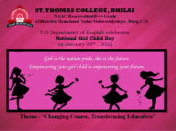



**St. Thomas College, Bhilai**

**P.G Department of English**

**Activity Report-2021-22**

**Day & Date:** (Monday) 24/01/2022

**Topic:** Changing Course, Transforming Education

**Activity:** Changing Course, Transforming Education

**Number of Beneficiaries:** 46

|  |  |  |
| --- | --- | --- |
| **Sl. No** | **Name of the Beneficiaries** | **Class** |
|  | Archana Besara | M.A. Sem IV |
|  | Dinkal Mahilwar | M.A. Sem IV |
|  | Garvita Agarwal | M.A. Sem IV |
|  | S. Nirosha | M.A. Sem IV |
|  | Sakshi Sainik | M.A. Sem IV |
|  | Manjulika Yadav | M.A. Sem IV |
|  | Pooja Sahu | M.A. Sem IV |
|  | Prince Abhishek | M.A. Sem IV |
|  | Hemant Korram | M.A. Sem IV |
|  | Hemant Dhruv | M.A. Sem IV |
|  | Ragini | M.A. Sem IV |
|  | Shubhang Das | M.A. Sem II |
|  | Bipasha Sokhey | M.A. Sem II |
|  | Aastha Temurkar | M.A. Sem II |
|  | Pragya Soni | M.A. Sem II |
|  | Aishwarya Sahu | M.A. Sem II |
|  | Jyoti Verma | M.A. Sem II |
|  | Lagan Khare | M.A. Sem II |
|  | Pragya Soni | M.A. Sem II |
|  | Aastha Ramteke | M.A. Sem II |
|  | Sanjay Deshmukh | M.A. Sem II |
|  | Shruti Daniel | M.A. Sem II |
|  | Umang Bajpayee | M.A. Sem II |
|  | Anshika Tripathi | M.A. Sem II |
|  | Naveen Daniel | M.A. Sem II |
|  | Pratiksha Mandal | M.A. Sem II |
|  | Gaurav Kamle | M.A. Sem II |
|  | Rimpi Shrivastava | M.A. Sem II |
|  | Isha Arnold | B.A III |
|  | S. Sweta | B.A III |
|  | S. Nimisha | B.A III |
|  | Mahek | B.A III |
|  | Sanskriti Bharadwaj | B.A III |
|  | Ria Saji | B.A III |
|  | Meenakshi Verma | B.A III |
|  | Shivani Awasthy | B.A II |
|  | Yindesh Kumar Sahu | B.A II |
|  | Khusboo Patnaik | B.A II |
|  | Leeza Lowansi | B.A II |
|  | Vohit Patel | B.A II |
|  | Nancy Banjare | B.A II |
|  | Harshita Jhole | B.A I |
|  | Garima Sahu | B.A I |
|  | Saleha | B.A I |
|  | Nupur Nagaria | B.A I |
|  | Sofia Ali | B.A I |



**St. Thomas College, Bhilai**

**P.G. Department of Chemistry**

**Activity Report-2021-22**

**Day & Date:** (Wednesday) 13/04/2022

Topic: Hands-On Training On Indian Patent Filing & Document Handling

**Activity:** Hands-On Training

**Number of Beneficiaries: 76**

P.G. Department of Chemistry, IQAC of St. Thomas College, Bhilai and APSGMNS Govt. P. G. College, Kawardha organized a one day webinar on Intellectual Property Rights. The resource person of the webinar was Dr. Vivekananda Mandal, Assistant Professor, Department of Pharmacy, Guru Ghasidas Central University, Bilaspur. Dr. James Mathew NAAC Coordinator and HOD, welcomed the virtual gathering. The webinar was conducted by Dr. Chanda Verma of St. Thomas College, Bhilai and concluded by Dr. Deepti Jangde, HOD, Department of Chemistry, Govt. P. G. College, Kawardha. Dr. Richa Mishra, IQAC Coordinator, Govt. College, Kawardha proposed the vote of thanks. The faculty expressed their gratitude to Rev. Fr. Dr. Joshi Varghese, (Administrator), Dr. M.G. Roymon (Principal) and Dr. Mariam Jacob (Principal in charge) for providing the necessary motivation for organizing the program. The webinar was made successful by assistance provided by Ms Mohini Sharma (Lecturer) and Mr. Anil Varghese (Technical Assistant), Department of Chemistry, St. Thomas College, Bhilai.

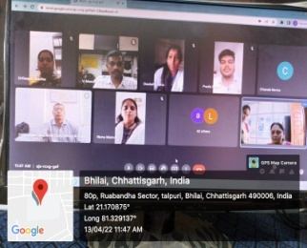



**St. Thomas College, Bhilai**

**P.G. Department of Chemistry**

**Activity Report-2021-22**

**Day & Date:** (Wednesday) 13/04/2022

Topic:Hands-On Training On Indian Patent Filing & Document Handling

**Activity:** Hands-On Training

**Number of Beneficiaries:76**

|  |  |  |  |
| --- | --- | --- | --- |
|  | Arvind | 45 | Anju Sahu |
|  | Leena | 46 | Anshu Bhattacharya |
|  | Dipti Sahu | 47 | Sakshi Yadav |
|  | Nayan Rajput | 48 | Lumendra Kumar |
|  | Pratik Rajput | 49 | Biresh Kumar Bhaskar |
|  | Deeksha Sahu | 50 | Priyanka Mudliyar |
|  | Yashmi Sahu | 51 | Buddhidatri Sinha |
|  | Prerna Gautam | 52 | Govinda |
|  | Ashu Chandrakar | 53 | Devkumari Chandrawanshi |
|  | Mayuri Singh | 54 | Surendra Kumar Mehar |
|  | Yashwant Kumar | 55 | Prerna Gautam |
|  | Dipti Sahu | 56 | Pooja Rao |
|  | Nayan Rajput | 57 | Manish Sahu |
|  | Chandrakiran Dilliwar | 58 | Khileshwari |
|  | Ashu Chandrakar | 59 | Surekha |
|  | Anshu Bhattacharya | 60 | Pooja Marai |
|  | Leena Sahu | 61 | Suruchi Chauhan |
|  | DIPTI SAHU | 62 | Chandrakanta Singh |
|  | Ashu Chandrakar | 63 | Santosh Kumar Dahariya |
|  | Pooja Rao | 64 | Netraj Sahu |
|  | Renuka Kumari | 65 | Shailja Sahu |
|  | Kajal Arora | 66 | Varsha |
|  | Nayan Rajput | 67 | Varsha Hatile |
|  | Palsingh | 68 | Anjani Jaiswal |
|  | Leelaram Singroul | 69 | Khemin Jaiswal |
|  | Govind Ram | 70 | Shakshi Kumari Mishra |
|  | Dinesh Kumar Dhurwey | 71 | Chandan Goswami |
|  | Motilal Bhaskar | 72 | Nohar |
|  | Gaurav Gautam | 73 | Dageshwar Sahu |
|  | Tarannum Khan | 74 | Manoj |
|  | Vibha Kaushik | 75 | Aakanksha Verma |
|  | Gulnaaz Parveen | 76 | Madhavi Sahu |
|  | Yonesh Banpela |
|  | Tarun Koshale |
|  | Harshita Yadav |
|  | Aanchal Kannoje |
|  | Komal Sahu |
|  | Komal Sahu |
|  | Aanchal Kannoje |
|  | Samarth Gupta |
|  | Bhuneshvar |
|  | Bindu Jangde |
|  | Sunita Lanjhikar |
|  | Jesna Saji |



**St. Thomas College, Bhilai**

**PG. Departmrnt of Commerce**

**Activity Report-2021-22**

**Day & Date:** (Sunday) 24/04/2022

**Topic:** Webinar on Emerging Management Carrier –Post Covid

**Activity:** Webinar

**Number of Beneficiaries:** 21

PG. Departmrnt of Commerce organized an exclusive webinar for the passing out batch of commerce students.The session enhanced the Knowledge, Skills, and Attitude of the students, especially during the current situation for students who would face the external environment in post COVID’19 scenario.

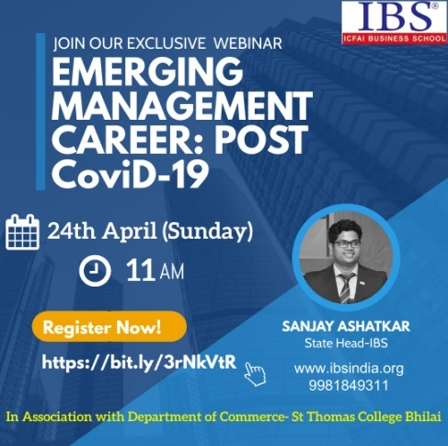



**St. Thomas College, Bhilai**

**PG. Departmrnt of Commerce**

**Activity Report-2021-22**

**Day & Date:** (Sunday) 24/04/2022

**Topic:** Webinar on Emerging Management Carrier –Post Covid

**Activity:** Webinar

**Number of Beneficiaries:** 21

|  |  |  |  |
| --- | --- | --- | --- |
| S.No | Names Of Students | S.No | Names Of Students |
|  | Anand Mishra | 11. | Sejal Jain |
|  | Fatima Imama | 12. | Nikhilesh Singh Thakur |
|  | Imroz | 13. | Samiksha Boratwar |
|  | Lijo Shaju | 14. | Amit Meshram |
|  | Lisa | 15. | Shubham Dinga |
|  | Nitish Dubey | 16. | Aryan sahu |
|  | Sachin Tiwari | 17. | Mili Mathew |
|  | Sakshi Gupta | 18. | Mohnish Sahu |
|  | Khushi Agarwal | 19. | D.Bhavika |
|  | Divy Singh | 20. | C.vivek |
| 21 | suryakant |  |  |



**St. Thomas College, Bhilai**

**Botany department**

**Activity Report-2021-22**

**Day & Date:** (Monday) 25/04/2022

**Topic:** Interactive talk on IPR

**Activity:** Interactive talk

**Number of Beneficiaries:** 37

The has organized an online talk on Intellectual Property Rights in association with Covenant Center for Development (CCD) for its M.Sc Botany students on Monday; 25.04.2022 at 11.00am in Botany Lab. Total 37 students attended the online talk.

Registration Link: <https://forms.gle/SMc1rxNvPoRXi52m7>

Google meet: <https://meet.google.com/hiz-ngii-kxc>

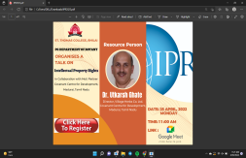



**St. Thomas College, Bhilai**

**Botany department**

**Activity Report-2021-22**

**Day & Date:** (Monday) 25/04/2022

**Topic:** Interactive talk on IPR

**Activity:** Interactive talk

**Number of Beneficiaries:** 37

|  |  |  |
| --- | --- | --- |
| S.No. | Name of the student | Class |
| 1 | Yukta | M.Sc I Sem |
| 2 | Damini | M.Sc I Sem |
| 3 | Heena | M.Sc I Sem |
| 4 | Rajiv Paul | M.Sc I Sem |
| 5 | Twinkle | M.Sc I Sem |
| 6 | Sujeet Minz | M.Sc I Sem |
| 7 | Devbharat | M.Sc I Sem |
| 8 | Sachin Sahu | M.Sc I Sem |
| 9 | Priyanka Sahu | M.Sc I Sem |
| 10 | Sanyam Gupta | M.Sc III Sem |
| 11 | Arti | M.Sc I Sem |
| 12 | Barkha pal | M.Sc I Sem |
| 13 | Seema Tete | M.Sc I Sem |
| 14 | Archana Sahu | M.Sc I Sem |
| 15 | Nisha Minj | M.Sc I Sem |
| 16 | Nikita Lakra | M.Sc I Sem |
| 17 | Vaishali | M.Sc I Sem |
| 18 | Damini Bhurya | M.Sc I Sem |
| 19 | Damini Thakur | M.Sc I Sem |
| 20 | Poonam | M.Sc III Sem |
| 21 | Madhusmita | M.Sc III Sem |
| 22 | Saroj Bharti | M.Sc III Sem |
| 23 | Padmini | M.Sc III Sem |
| 24 | Anjali Sinha | M.Sc III Sem |
| 25 | Naveen Kumar | M.Sc III Sem |
| 26 | Priyanka Verma | M.Sc III Sem |
| 27 | Hemant Kr | M.Sc III Sem |
| 28 | Priyanshi bhagat | M.Sc III Sem |
| 29 | Megha Dewangan | M.Sc III Sem |
| 30 | Anshumala | M.Sc III Sem |
| 31 | Shubham Dewangan | M.Sc III Sem |
| 32 | Neha Singh | M.Sc III Sem |
| 33 | Vikas Ramkete | M.Sc III Sem |
| 34 | Deepika | M.Sc III Sem |
| 35 | Oshin Rawat | M.Sc III Sem |
| 36 | Sonali Dey | B.Sc III |
| 37 | Pushpendra | B.Sc III |



**St. Thomas College, Bhilai**

**PG. Department of Commerce**

**Activity Report-2021-22**

**Day & Date:** (Friday) 27/05/2022

**Topic:** Incubation and Start-ups in Higher Education

**Activity:** Incubation and Start-ups in Higher Education

**Number of Beneficiaries**: (STC-90)

The PG. Department of Commerce under the aegis of departmental Association Commzenith , ED Cell and Institutional Innovation CouncilAssociation,in collaboration with our MoU Patners Rungta College of Engineering and Technology, Bhilai and Smt. Radhadevi Goenka College for Women organisd webinar on the topic “ Incubation ans Start ups in Higher Education” On 27 th May 2022. Dr, Manoj Vargese, Dean IIC, RCET Bhilai and Mr. Varun Agrawal, Owner

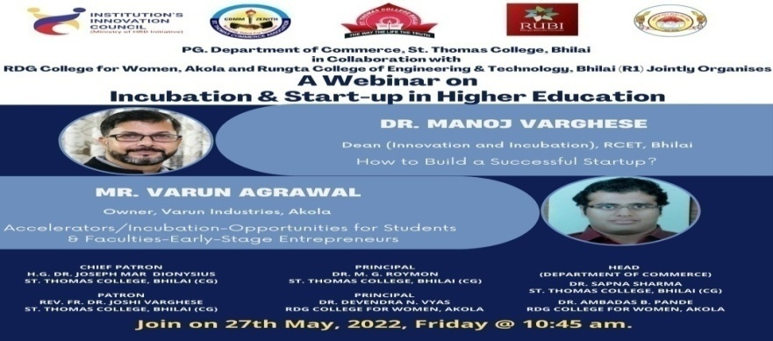

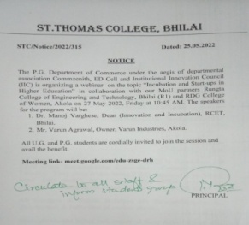



**St. Thomas College, Bhilai**

**PG. Department of Commerce**

**Activity Report-2021-22**

**Day & Date:** (Friday) 27/05/2022

**Topic:** Incubation and Start-ups in Higher Education

**Activity:** Incubation and Start-ups in Higher Education

**Number of Beneficiaries: (STC-90)**

|  |  |  |  |  |  |
| --- | --- | --- | --- | --- | --- |
|  | **Timestamp** | **Email:** | **Full Name:** | **Nature of participant:** | **Mobile No.** |
| 1 | 5/26/2022 15:01:42 | ankushsahu572@gmail.com | Ankush sahu | Student | 7587256120 |
| 2 | 5/26/2022 15:02:00 | ayushiisunil18@gmail.com | Ayushi Sunil | Student | 7806067859 |
| 3 | 5/26/2022 15:02:37 | manassundrani1000@gmail.com | Manas sundrani | Student | 9827267370 |
| 4 | 5/26/2022 15:02:42 | shailesh031201@gmail.com | Shailesh sharma | Student | 7024664949 |
| 5 | 5/26/2022 15:03:25 | deeptideshmukh53728@gmail.com | Deepti deshmukh | Student | 8269355138 |
| 6 | 5/26/2022 15:04:21 | blossumshristi@gmail.com | Shristi More | Student | 7415439389 |
| 7 | 5/26/2022 15:05:13 | leenapatel.lp2908@gmail.com | Leena patel | Student | 9977884791 |
| 8 | 5/26/2022 15:05:58 | roshnikumari43120@gmail.com | BARKHA KUMARI | Student | 8709134950 |
| 9 | 5/26/2022 15:08:47 | varshapaikra28@gmail.com | Varsha Paikra | Student | 7477042028 |
| 10 | 5/26/2022 15:23:50 | sakshigupta2931@gmail.com | Sakshi Gupta | Student | 9887025849 |
| 11 | 5/26/2022 15:28:08 | pranaytiwari230302@gmail.com | Pranay Tiwari | Student | 6261122234 |
| 12 | 5/26/2022 16:32:16 | Keshavpisda2000@gmail.com | Keshav Prasad Pisda | Student | 9424157993 |
| 13 | 5/26/2022 16:35:15 | vinitakanwar28@gmail.com | VINITA KANWAR | Student | 7987654746 |
| 14 | 5/26/2022 16:36:26 | tulsich002@gmail.com | Tulsi chandra | Student | 8349790105 |
| 15 | 5/26/2022 16:45:08 | shrutichouhan06@gmail.com | Shruti Chouhan | Student | 6266466440 |
| 16 | 5/26/2022 17:19:13 | ayushimahi74@gmail.com | AYUSHI MISHRA | Student | 6261716204 |
| 17 | 5/26/2022 17:26:36 | dewanganshaivi64@gmail.com | Shaivi Dewangan | Student | 9981825889 |
| 18 | 5/26/2022 17:38:55 | rehanqureshi4421@gmail.com | Mohd Rehan Qureshi | Student | 8602904421 |
| 19 | 5/26/2022 18:25:35 | tiggasahil20@gmail.com | Sahil tigga | Student | 7803923470 |
| 20 | 5/26/2022 18:35:19 | smruti1142002@gmail.com | Smruti Rekha Sahoo | Student | 8103625010 |
| 21 | 5/26/2022 19:07:09 | ashish719223@gmail.com | Ashish verma | Student | 8103172054 |
| 22 | 5/26/2022 19:18:25 | bikashmahant3@gmail.com | Vikash mahanto | Student | 6267059233 |
| 23 | 5/26/2022 19:19:39 | yahejkelkhalkho44@gmail.com | Yahejkel Khalkho | Student | 7415748614 |
| 24 | 5/26/2022 19:19:44 | shailjadubey497@gmail.com | ShailjaDubey | Student | 9343863830 |
| 25 | 5/26/2022 19:20:18 | kajaluranw1@gmail.com | Kajal Uranw | Student | 8305529918 |
| 26 | 5/26/2022 19:21:28 | nayakchitra871@gmail.com | Priyanka nayak | Student | 7222938251 |
| 27 | 5/26/2022 19:22:49 | pinku93000@gmail.com | Priyanka Singh | Student | 7974711261 |
| 28 | 5/26/2022 19:25:27 | Shwetapatil021101@gmail.com | Shweta patil | Student | 8349731708 |
| 29 | 5/26/2022 19:25:34 | jshivani2604@gmail.com | J Shivani | Student | 8103520979 |
| 30 | 5/26/2022 19:28:17 | Singhaakanksha21@gmail.com | Aakanksha Singh | Student | 9770177558 |
| 31 | 5/26/2022 19:33:16 | Shristi20sharma11@gmail.com | Shristi Sharma | Student | 8770632735 |
| 32 | 5/26/2022 19:35:04 | diptisahudmt@gmail.com | Dipti sahu | Student | 6261982432 |
| 33 | 5/26/2022 19:35:20 | Sapnarajwade1302@gmail.com | Sapna kumari rajwade | Student | 7415695172 |
| 34 | 5/26/2022 19:39:40 | shrutisoni7581@gmail.com | Shruti soni | Student | 9713700909 |
| 35 | 5/26/2022 19:40:44 | abhinavtigga22@gmail.com | Abhinav Tigga | Student | 6263860537 |
| 36 | 5/26/2022 19:43:58 | jaageshhojjha234@gmail.com | Jagesh ojha | Student | 6265654480 |
| 37 | 5/26/2022 19:47:54 | bhowmickshailly@gmail.com | Bhowmick Shailly | Student | 9691394304 |
| 38 | 5/26/2022 19:49:39 | mewsisorg@gmail.com | Mohd Imroz | Student | 9109360993 |
| 39 | 5/26/2022 19:55:44 | Snehadhruw29@gmail.com | Sneha Dhruw | Student | 7746021119 |
| 40 | 5/26/2022 20:10:47 | anuragsingh85732@gmail.com | Anurag Singh | Student | 6266808914 |
| 41 | 5/26/2022 20:24:22 | tsoni0203@gmail.com | Tanushree soni | Student | 7999505006 |
| 42 | 5/26/2022 20:40:20 | Sunitabhuwal@gmail.com | Dr. Sunita Kshatriya | Academician | 9109727779 |
| 43 | 5/26/2022 20:46:42 | ppriyansh2001@gmail.com | Priyanshu Jha | Student | 7389543023 |
| 44 | 5/26/2022 21:18:29 | sangeetamourya771@gmail.com | Sanchit kumar | Student | 6265092097 |
| 45 | 5/26/2022 21:22:42 | prakritisoan20@gmail.com | Prakriti soan | Student | 8889128548 |
| 46 | 5/26/2022 21:23:40 | souravsinghakasameul2018@gmail.com | Sourav singh | Student | 7723834776 |
| 47 | 5/26/2022 21:25:25 | rosepriyasolanki1@gmail.com | Rosepriya solanki | Student | 8305127312 |
| 48 | 5/26/2022 21:31:47 | deeptisinha405@gmail.com | Deepti Sinha | Student | 8305016649 |
| 49 | 5/26/2022 21:46:13 | manshimanikpuri77@gmail.com | Mansi manikpuri | Student | 9589114535 |
| 50 | 5/26/2022 21:49:30 | jitubhai0049@gmail.com | Jitendra Verma | Student | 7000140152 |
| 51 | 5/26/2022 21:56:54 | bhaskarsahu2323@gmail.com | Bhaskar Sahu | Student | 8319129264 |
| 52 | 5/26/2022 21:58:53 | pushpendrabhaskar1379@gmail.com | Pushpendra Bhaskar | Student | 9109899364 |
| 53 | 5/26/2022 22:11:00 | sanjivani.naik99@gmail.com | Sanjivani naik | Student | 9284995382 |
| 54 | 5/26/2022 22:18:15 | rinceythomas23@gmail.com | Dr. Rincey B. Abraham | Academician | 9827992517 |
| 55 | 5/26/2022 23:27:45 | svarkey07@gmail.com | Dr Sheeja Varkey | Academician | 9406253377 |
| 56 | 5/27/2022 0:51:54 | sharonsunil64@gmail.com | Sharon Sunil | Student | 7898332421 |
| 57 | 5/27/2022 6:50:36 | ns089175@gmail.com | Neha sahu | Student | 6261087996 |
| 58 | 5/27/2022 7:00:29 | jharnav423@gmail.com | Jharna Verma | Student | 7974880100 |
| 59 | 5/27/2022 7:28:09 | srishtimandavi7@gmail.com | Srishti Mandavi | Student | 9302095486 |
| 60 | 5/27/2022 7:46:47 | nishumishra1098@gmail.com | Nishu mishra | Student | 7722947421 |
| 61 | 5/27/2022 8:23:21 | anjalidhruw856@gmail.com | Anjali Dhruw | Student | 8120079133 |
| 62 | 5/27/2022 8:35:26 | guptqpawan07@gmail.com | Pawan Kumar Gupta | Student | 7987774664 |
| 63 | 5/27/2022 8:39:19 | ananyaneha2002@gmail.com | Ananya Verma | Student | 9301803808 |
| 64 | 5/27/2022 8:42:52 | sontubhai143@gmail.com | SUBEER MANDAL | Student | 9406395871 |
| 65 | 5/27/2022 9:08:15 | ansht611@gmail.com | Ansh Tiwari | Student | 6264518705 |
| 66 | 5/27/2022 9:14:00 | himanshityagi5402@gmail.com | Himanshi Tyagi | Student | 7983994434 |
| 67 | 5/27/2022 9:18:43 | aranchakujur05@gmail.com | Arancha Kujur | Student | 9669225139 |
| 68 | 5/27/2022 10:14:23 | pankajkumarkhandhe725@gmail.com | Pankaj Kumar Khandhe | Student | 7447039725 |
| 69 | 5/27/2022 10:39:43 | ujsupe@gmail.com | DR. UJJWALA SUPE | Academician | 9827460468 |
| 70 | 5/27/2022 10:40:07 | riyasharma192000@gmail.com | Riya Sharma | Student | 9343442829 |
| 71 | 5/27/2022 10:40:42 | shefaligoswami44@gmail.com | Sefali | Other | 7987331528 |
| 72 | 5/27/2022 10:48:51 | sumitjethwa0787@gmail.com | sumit jethwa | Student | 6263237250 |
| 73 | 5/27/2022 10:49:06 | sahushailja251@gmail.com | Shailja sahu | Student | 7691976171 |
| 74 | 5/27/2022 10:49:57 | aditi.acharya0919@gmail.com | Aditi Acharya | Academician | 7898094759 |
| 75 | 5/27/2022 10:51:24 | priyadarshani9jan@gmail.com | Priya Darshani | Student | 9399711966 |
| 76 | 5/27/2022 10:54:35 | Pragyabhagat1502@gmail.com | Pragya Bhagat | Student | 9691328640 |
| 77 | 5/27/2022 11:02:40 | riyasara008@gmail.com | Riya Sara Jijy | Student | 7489950045 |
| 78 | 5/27/2022 11:02:45 | neelamgandhi28@gmail.com | Dr. Neelam Gandhi | Academician | 8109136477 |
| 79 | 5/27/2022 11:09:04 | surekhabhilaistc@gmail.com | Dr Surekha Jawade | Other | 9424125079 |
| 80 | 5/27/2022 11:09:07 | dhananjay252verma@gmail.com | Dhananjay Verma | Student | 9893053860 |
| 81 | 5/27/2022 11:17:23 | tjanki876@gmail.com | Janki | Student | 9399691963 |
| 82 | 5/27/2022 11:18:44 | jagritivaishnav02@gmail.com | Jagriti Vaishnav | Student | 6263647191 |
| 83 | 5/27/2022 11:21:52 | Seenucool000@gmail.com | Disha diwan | Student | 7000074624 |
| 84 | 5/27/2022 11:50:31 | pranjalsoni318@gmail.com | Pranjal Soni | Student | 9109300673 |
| 85 | 5/27/2022 11:52:49 | riteshk012002@gmail.com | Ritesh kumar | Student | 9111040856 |
| 86 | 5/27/2022 12:15:06 | shriyadeepti68@gmail.com | Shriya Santosh | Student | 7869978885 |
| 87 | 5/27/2022 12:46:02 | aditijangade27@gmail.com | Aditi Jangade | Student | 9630461893 |
| 88 | 5/27/2022 13:33:57 | navvinnair669@gmail.com | N.Naveen | Student | 7717757132 |
| 89 | 5/27/2022 23:55:31 | bhabhavikasharma501@gmail.com | Bhavika Sharma | Student | 7879469747 |
| 90 | 5/31/2022 11:08:48 | xalxosachin575@gmail.com | Sachin xalxo | Student | 6260757769 |



**St. Thomas College, Bhilai**

**Botany Department**

**Activity Report-2021-22**

**Day & Date: (**Thursday),29.03.2022-(Friday) 08.04.2022

**Topic:** Certificate programme on Soil Analysis

**Activity:** Certificate programme

**Number of Beneficiaries:** 40

The Botanical Association organized a 10 day Certificate Programme on Soil Analysis from Thursday 29.03.2022 – Friday 08.04.2022 11.00 am – 2.00 pm. Total 40 students took benefit of the programme. The aim of the certificate program is to create awareness about soil science among students. Hand-on practicals were also performed by the participants. The registered participants also visited the Soil analysis Lab (Govt. Lab) Bhilaiand learnt how to do the testing of the soil sample.

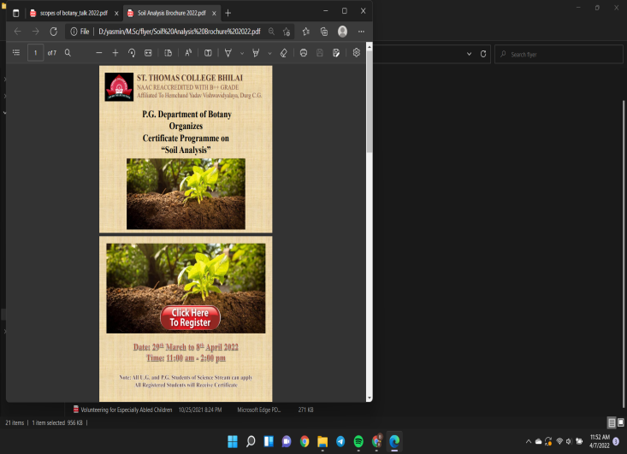





**St. Thomas College, Bhilai**

**Botany Department**

**Activity Report-2021-22**

**Day & Date: (**Thursday),29.03.2022-(Friday) 08.04.2022

**Topic:** Certificate programme on Soil Analysis

**Activity:** Certificate programme

**Number of Beneficiaries:** 40

|  |  |  |
| --- | --- | --- |
| **S.No.** | **Name of the Student** | **Class** |
| **1** | Aafreen Hussain | **B.Sc II** |
| **2** | Dev bharat | **M.Sc I Sem** |
| **3** | Sonali Dey | **B.Sc III** |
| **4** | Aniketa Bhardwaj | **M.Sc III Sem** |
| **5** | Priyanka sahu | **M.Sc I Sem** |
| **6** | Sunita sahu | **M.Sc I Sem** |
| **7** | Barkha Pal | **M.Sc I Sem** |
| **8** | Sachin Sahu | **M.Sc I Sem** |
| **9** | Pramila sahu | **B.Sc II** |
| **10** | Khyati Pandey | **B.Sc II** |
| **11** | Tripti Shahni | **B.Sc II** |
| **12** | Madhu Smita Tirkey | **M.Sc III Sem** |
| **13** | Sanyam Gupta | **M.Sc III Sem** |
| **14** | Vaishali Chaubey | **M.Sc I Sem** |
| **15** | Sulekha Lakra | **M.Sc I Sem** |
| **16** | Damini bhuarya | **M.Sc I Sem** |
| **17** | Sujeet Minj | **M.Sc I Sem** |
| **18** | Srishti mandavi | **M.Sc I Sem** |
| **19** | Hemant Kumar | **M.Sc III Sem** |
| **20** | Anjali Sinha | **M.Sc III Sem** |
| **21** | Poonam verma | **M.Sc III Sem** |
| **22** | Saroj Bharti | **M.Sc III Sem** |
| **23** | Oshin Rawate | **M.Sc III Sem** |
| **24** | Ekta Rani Netam | **M.Sc III Sem** |
| **25** | Damini bhuarya | **M.Sc III Sem** |
| **26** | Archana Sahu | **M.Sc I Sem** |
| **27** | Yukta Harmukh | **M.Sc I Sem** |
| **28** | Vikash ramteke | **M.Sc III Sem** |
| **29** | Poonam verma | **M.Sc III Sem** |
| **30** | Priyanka sahu | **M.Sc III Sem** |
| **31** | Yukta Harmukh | **M.Sc III Sem** |
| **32** | Pushpendra Bhaskar | **M.Sc III Sem** |
| **33** | Damini Thakur | **M.Sc III Sem** |
| **34** | Heena Sahu | **M.Sc III Sem** |
| **35** | Priyanshi Bhagat | **B.Sc II** |
| **36** | Bidhanshuk Dutta | **B.Sc II** |
| **37** | Arti | **B.Sc II** |
| **38** | TUMESHWARi DEWANGAN | **M.Sc I Sem** |
| **38** | Domeshwari | **M.Sc I Sem** |
| **39** | Rajiv Paul | **M.Sc I Sem** |
| **40** | Nikita | **M.Sc I Sem** |



**St. Thomas College, Bhilai**

**Department of Physics and Electronics**

**Activity Report-2021-22**

**Day & Date:** (Monday) 21/02/2022(Friday) 04/03/2022

**Topic:** Online Certificate Course from IIRS-ISRO (95) Global Navigation Satellite System and Location based services

**Activity:** Online Certificate Course

**Number of Beneficiaries:** 05

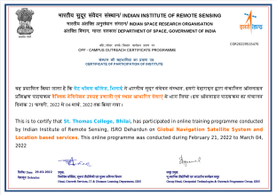



**St. Thomas College, Bhilai**

**Department of Physics and Electronics**

**Activity Report-2021-22**

**Day & Date:** (Monday) 21/02/2022(Friday) 04/03/2022

**Topic:** Online Certificate Course from IIRS-ISRO (95) Global Navigation Satellite System and Location based services

**Activity:** Online Certificate Course

**Number of Beneficiaries:** 05

| **Sr. No.** | **Name Of Participant** | **Class** | **Sr. No.** | **Name Of Participant** | **Class** |
| --- | --- | --- | --- | --- | --- |
| 1 | Aayushi Pandey | IV Sem | 4 | Ruchika Sen | II Sem |
| 2 | Shashank Santoshwar | IV Sem | 5 | **HITESH KUMAR** | **II Sem** |
| 3 | Priya Sai | IV Sem | 6 | **ROJAN JOY** | **Staff** |



**St. Thomas College, Bhilai**

**Department of Physics and Electronics**

**Activity Report-2021-22**

**Day & Date:** (Monday) 07/03/2022(Thursday) 17/03/2022

**Topic:** Certificate course from IIRS-ISRO: (96) Hyper Spectral and Microwave Remote Sensing Techniques for Geological Studies.

**Activity:** Online Certificate Course

**Number of Beneficiaries:** 04

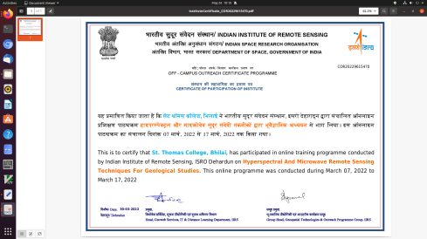



**St. Thomas College, Bhilai**

**Department of Physics and Electronics**

**Activity Report-2021-22**

**Day & Date:** (Monday) 07/03/2022(Thursday) 17/03/2022

**Topic:** Certificate course from IIRS-ISRO: (96) Hyper Spectral and Microwave Remote Sensing Techniques for Geological Studies.

**Activity:** Online Certificate Course

**Number of Beneficiaries:** 04

| **Sr. No.** | **Name of Participant** | **Class** | **Sr. No.** | **Name of Participant** | **Class** |
| --- | --- | --- | --- | --- | --- |
| 1 | Rupali Verma | IV Sem | 3 | Tulika Harshit | Staff |
| 2 | Kusumanjali Verma | IV Sem | 4 | Sonu Kumar Singh | Staff |



**St. Thomas College, Bhilai**

**P.G. Department of Biotechnology and Microbiology**

**Activity Report-2021-22**

**Day & Date:** (Saturday) 11/04/2022

**Topic: Scientific Illustrations and Scientific Communications**

**Activity:** Alumni Interaction

**Number of Beneficiaries:** 60

An Alumni Interaction cum lecture was organized the P.G. Department of Biotechnology and Microbiology on “Scientific illustrations and scientific communications” to make students aware about various career options in this field. It was organized on 11.4.2022. Speaker of the session was an alumunus Dr. Disha Chauhan, Entrepreneurship consultant C-camp Bangalore. Students gave highly positive feedback on the session. They learned about various options like drawing, editing, drafting and illustrating. They also engaged in discussions for different job opportunities in the field of life science. The numbers of beneficiaries were 60.

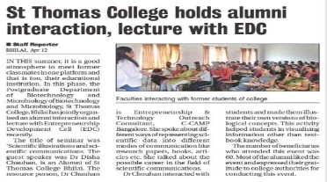



**St. Thomas College, Bhilai**

**P.G. Department of Biotechnology and Microbiology**

**Activity Report-2021-22**

**Day & Date:** (Saturday) 11/04/2022

**Topic: Scientific Illustrations and Scientific Communications**

**Activity:** Alumni Interaction

**Number of Beneficiaries:** 60

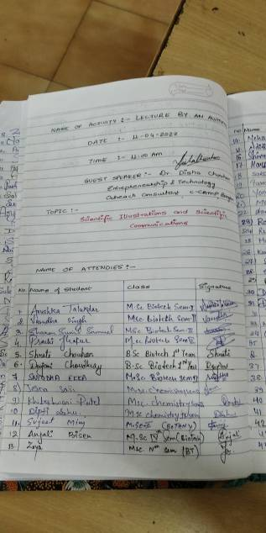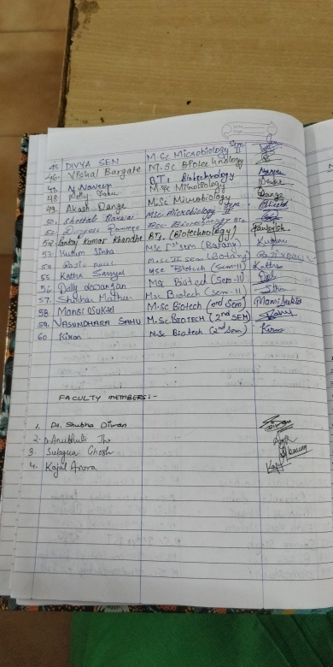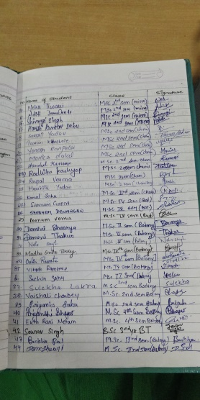



**St. Thomas College, Bhilai**

**P.G. department of biotechnology and microbiology**

**Activity Report-2021-22**

**Day & Date:** (Friday) 17/05/2022

**Topic: Bio-organic Preparations Development in Farmer’s Fields for Sustainable Agriculture**

**Activity:** Seminar

**Number of Beneficiaries:** 46

A seminar was organized by The P.G. department of biotechnology and microbiology on “Bioorganic Preparations Development in farmer’s field for sustainable agriculture” in collaboration with its MoU partner Farm Labs, Pune to make students aware about different types of Bioorganic farming practices one can take up. They also learned about the future broad applicability of learning this practice. It was organized on 17.5.2022. Dr. Santosh Chavan, Director of Farm Labs, talked about organic preparations and its applicability in details. He also spoke about different methods and different practices that can be taken up by students in an early phase of their life which can later on help in a better environment.

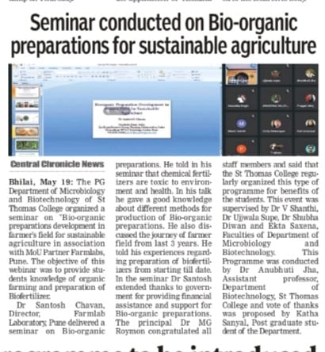

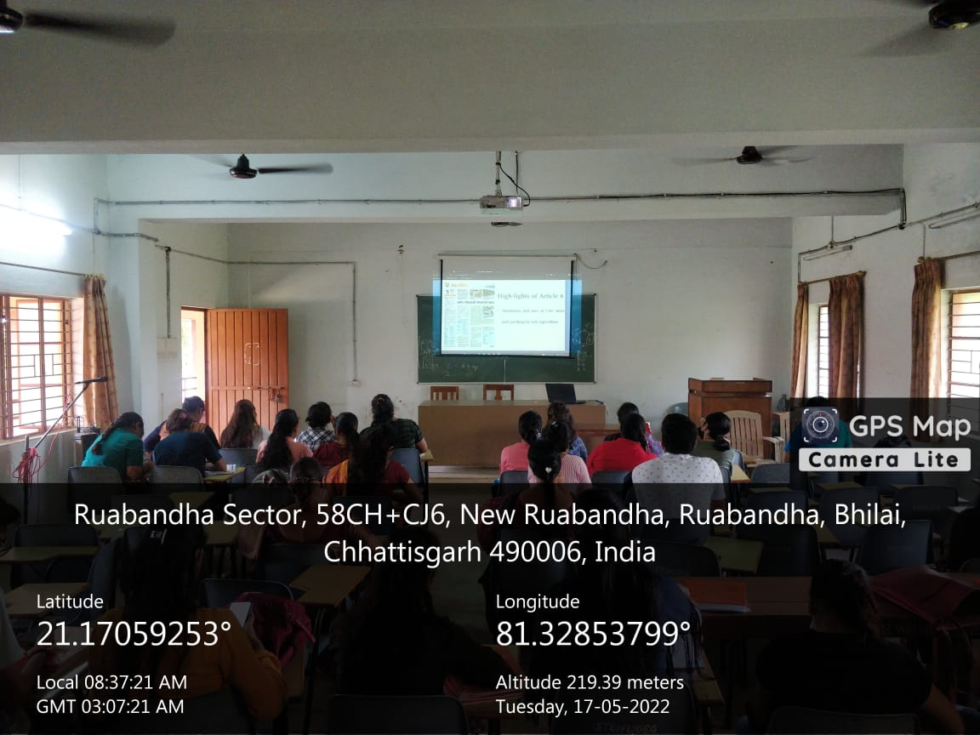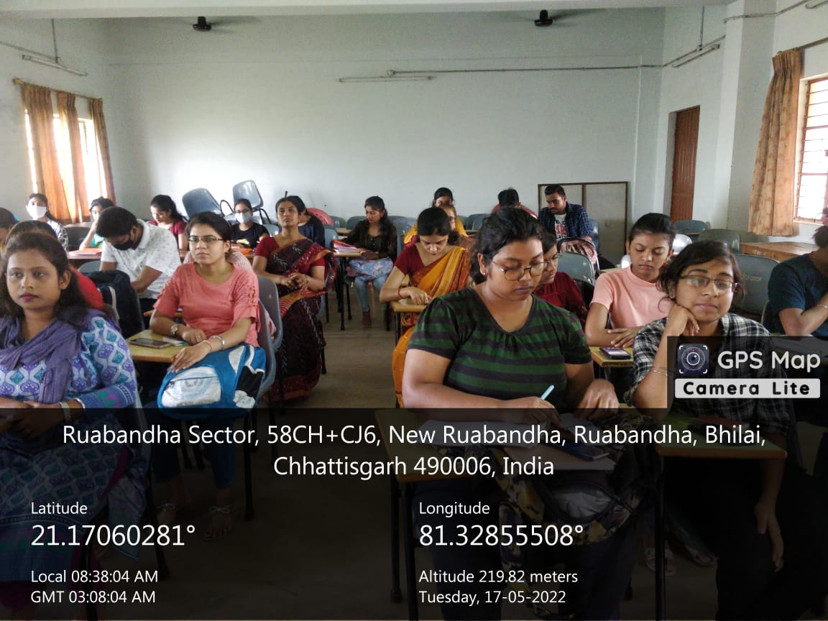



**St. Thomas College, Bhilai**

**P.G. department of biotechnology and microbiology**

**Activity Report-2021-22**

**Day & Date:** (Friday) 17/05/2022

**Topic: Bio-organic Preparations Development in Farmer’s Fields for Sustainable Agriculture**

**Activity:** Seminar

**Number of Beneficiaries:** 46

A seminar was organized by The P.G. department of biotechnology and microbiology on “Bioorganic Preparations Development in farmer’s field for sustainable agriculture” in collaboration with its MoU partner Farm Labs, Pune to make students aware about different types of Bioorganic farming practices one can take up. They also learned about the future broad applicability of learning this practice. It was organized on 17.5.2022. Dr. Santosh Chavan, Director of Farm Labs, talked about organic preparations and its applicability in details. He also spoke about different methods and different practices that can be taken up by students in an early phase of their life which can later on help in a better environment.





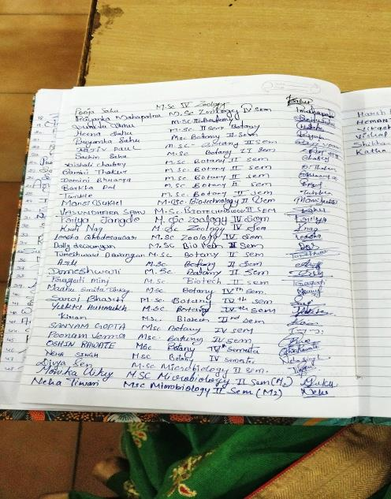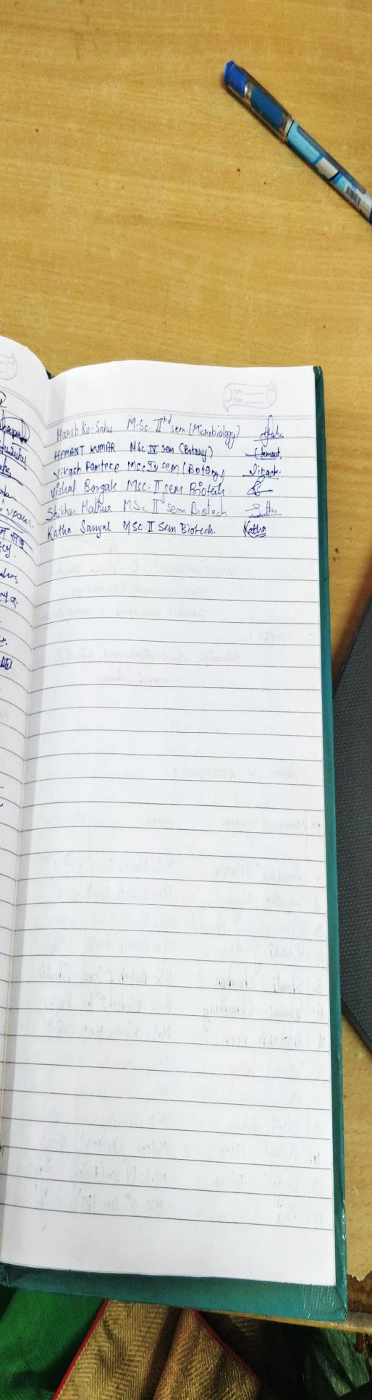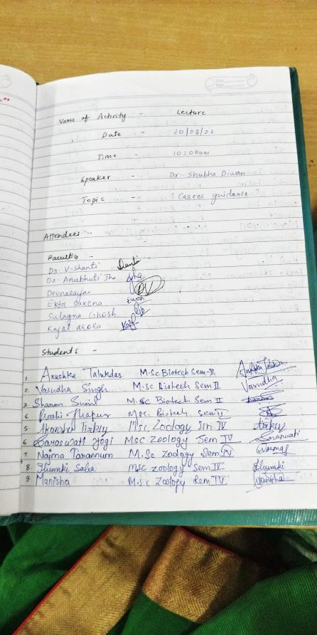





**St. Thomas College, Bhilai**

**Department of Physics and Electronics**

**Activity Report-2021-22**

**Online Certificate Course from IIRS-ISRO**

**Day and Date: 18.04.2022 to 29.04.2022**

**Activity:**  **Online Certificate Course**

**Name of the Course : (97) Advanced Geospatial technologies for Disaster Risk**

**Reduction (DRR)**

**No. of Beneficiaries: 02 Students + 3 Staff**

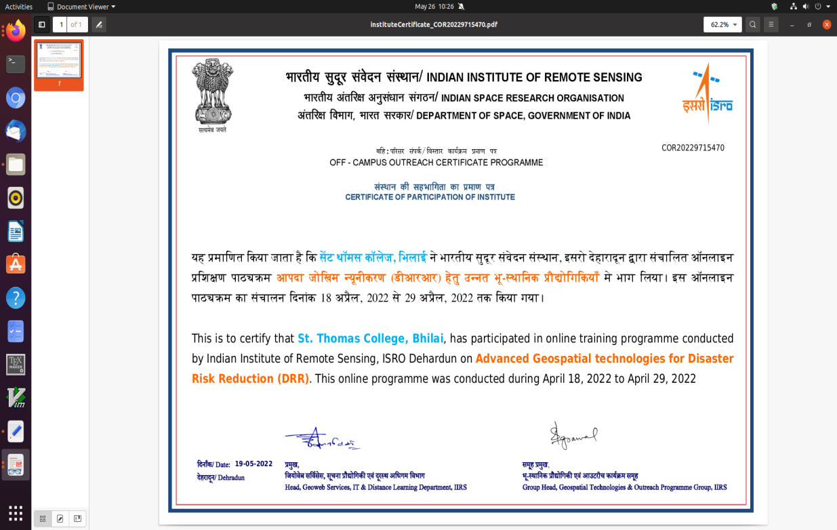



**St. Thomas College, Bhilai**

**Department of Physics and Electronics**

**Activity Report-2021-22**

Online Certificate Course from IIRS-ISRO

Day and Date: 18.04.2022 to 29.04.2022

Activity: Online Certificate Course

Name of the Course : (97) Advanced Geospatial technologies for Disaster Risk

Reduction (DRR)

No. of Beneficiaries: 02 Students + 3 Staff

| **Sr. No.** | **Name of Participant** | **Class** | **Sr. No.** | **Name of Participant** | **Class** |
| --- | --- | --- | --- | --- | --- |
| 1 | MR. ROJAN JOY | Staff | 4 | Tulika Harshit | Staff |
| 2 | MR. GALESHWAR | IV Sem | 5 | Sonu Kumar Singh | Staff |
| 3 | MS. AYUSHI SONI | IV Sem |  |  |  |



**St. Thomas College, Bhilai**

**PG Department of Commerce**

**Activity Report-2021-22**

**Day and Date:** (Saturday) 18/09/ 2021

**Topic:** Entrepreneurship Skill for Start-ups, Need of the Hour' A Webinar on Entrepreneurship Skills

**Activity:** A Webinar on Entrepreneurship Skills

**Number of Beneficiaries:** 85

Under the aegis of Commzenith of PG department of commerce in collaboration with IBS (ICFA) Business School organized student development programme on the topic “Entrepreneurship Skills for Startups “on 18th September 2021. Prof. Surjyabrat Buragohain Queensland University of Technology Australia was the resource person on the occasion.

Along with the theoretical education, this program was organized for the overall development of students so that entrepreneurship knowledge could be developed in the students. Ms. Jayshree Roy an Alumni of St. Thomas Colege deparmrnt of commerce also shared her experiences with the students and urged students to come forward and face the competitive world.

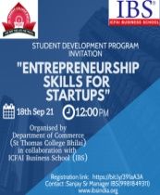



**St. Thomas College, Bhilai**

**PG Department of Commerce**

**Activity Report-2021-22**

**Day and Date:** (Saturday) 18/09/ 2021

**Topic:** Entrepreneurship Skill for Start-ups, Need of the Hour' A Webinar on Entrepreneurship Skills

**Activity:** A Webinar on Entrepreneurship Skills

**Number of Beneficiaries:** 85

The following students participated Entrepreneurship Skill for Start-ups, Need of the Hour'

A Webinar on Entrepreneurship Skills by ICFAI on 18th September 2021.

|  |  |  |  |
| --- | --- | --- | --- |
| S. No | Names of Students | S. No | Names of Students |
| 1. | Tarun rathore | 28 | Harshit Jain |
| 2 | Nitish Kumar | 29 | Indrajeet sahu |
| 3 | Harsh Arora | 30 | Jay Kumar Kande |
| 4 | Meenakshi | 31 | Jyoti Ghosh |
| 5 | Vishak Kumar | 32 | Karan Khalkho. |
| 6 | Pallavi Yadav | 33 | Komal Dhanwani |
| 7 | Vidya Dewangan | 34 | Lekha Thakur |
| 8 | Ashutosh Gupta | 35 | Madhu Kumari |
| 9 | Sakshi | 36 | Mansi Nishad |
| 10 | Dhanlaxmi Painkra | 37 | Md. Atif Khan |
| 11 | Rachit Yogi | 38 | Megha Sahu |
| 12 | Kunal Khalkho | 39 | Muskan Chopda |
| 13 | Divy Singh Parthar | 40 | N.V.S. Sushmita |
| 14 | Dumesh Kumar Sahu | 41 | Neeraj Suprim |
| 15 | Ekta Jobanputtra | 42 | Nitesh Bhoi |
| 16 | Faizaan Hussain | 43 | Harshit Jain |
| 17 | Fardeen Hussain | 45 | Indrajeet sahu |
| 18 | Farough Aukaf Khan | 46 | Anamika Mandal |
| 19 | Firdaush Anjum | 47 | Anil Sahu |
| 20 | Garima Chandra | 48 | Anjali Jaiswal |
| 21 | Gaurav Baghel | 49 | Anshika Vishwakarma |
| 22 | Gaurav Chandrakar | 50 | Anamika Mandal |
| 23 | Gavesh Kumar Sahu | 51 | Ketan Thakur |
| 24 | Ghreetika Sidar | 52 | Lakshya Nirmal |
| 25 | Gibbs Pramod | 53 | M Anuradha |
| 26 | Girish Kumar Paraste | 54 | Manoj Singh |
| 27 | Divy Singh Parthar | 55 | Ketan Thakur |

|  |  |  |  |
| --- | --- | --- | --- |
| S. No | Names of Students | S. No | Names of Students |
| 56 | Ruchi Lal | 83 | Neha Gandharva |
| 57 | S. Kusum | 84 | Nisha Jambhulkar |
| 58 | Sakshi | 85 | Palak Lilhare |
| 59 | Sambodhi Wahane |
| 60 | Sana Parveen |
| 61 | Sanchaita Bhattacharjee |
| 62 | Susmita Gupta |
| 63 | Thoufeeq Ahmad |
| 64 | Vanshika Jaiswal |
| 65 | Vedant Tiwari |
| 66 | Vikram Biswas |
| 67 | Vivek Shah |
| 68 | Yogita Verma |
| 69 | Yukta Gabel |
| 70 | Prabhat Kumar Bhagat |
| 71 | Pushpak Kundley |
| 72 | A Ruchi |
| 73 | Abhilash Mahto |
| 74 | Adarsh Nishad |
| 75 | Akanksha Nareti |
| 76 | Akhil C Thomas |
| 77 | Alok Gupta |
| 78 | Amitesh Chandrakar |
| 79 | Shubham Sonkar |
| 80 | Varidhi Pandey |
| 81 | Vishal Sharma |
| 82 | Mukesh Nayak |