P G Department of Botany

Resources in Laboratory

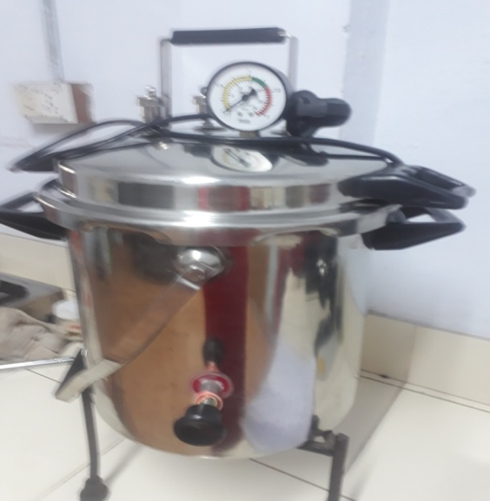  Name of the Instrument: Autoclave  Company Name: Shiva Instruments | 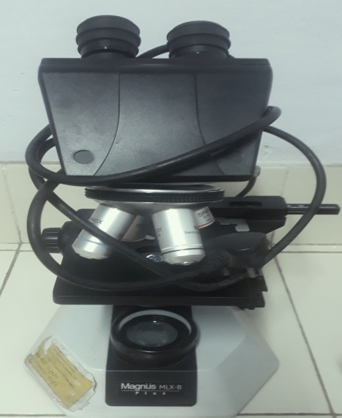  Name of the Instrument: Binocular Microscope  Company Name: Micronoptik
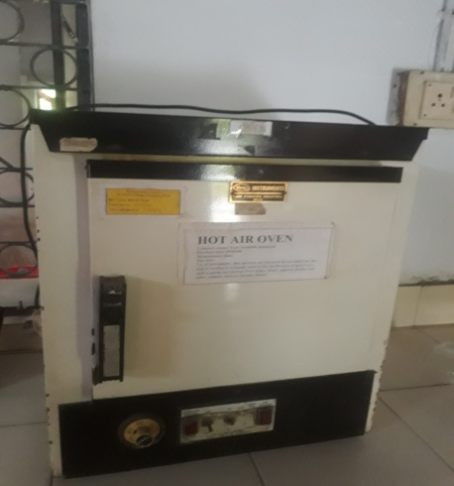  Name of the Instrument: Hot Air Oven  Company Name: Yorco Instruments | 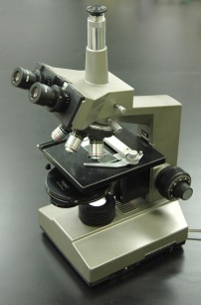  Name of the Instrument: Phase Contrast Microscope  Company Name: Magnus MLX-B Plus

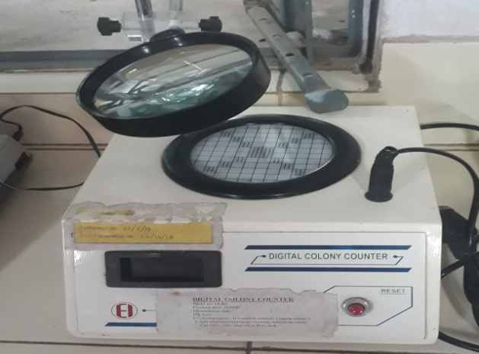  Name of the Instrument: Digital Colony Counter  Company Name: 361 EI | 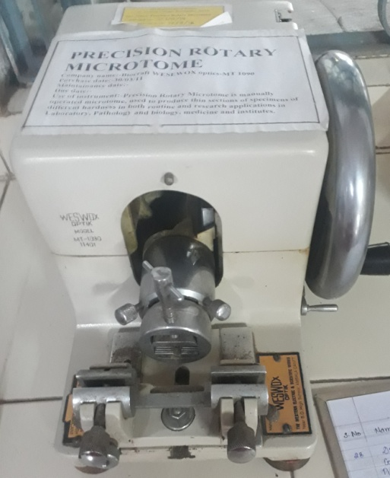  Name of the Instrument: Precision Rotary Microtome  Company Name: Biocraft
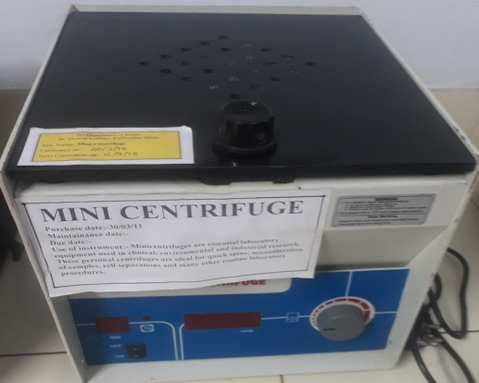  Name of the Instrument: Precision Rotary Microtome  Company Name: Biocraft | 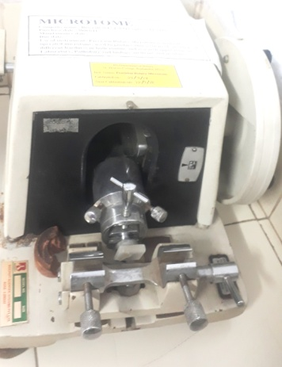  Name of the Instrument: Precision Rotary Microtome  Company Name: Biocraft

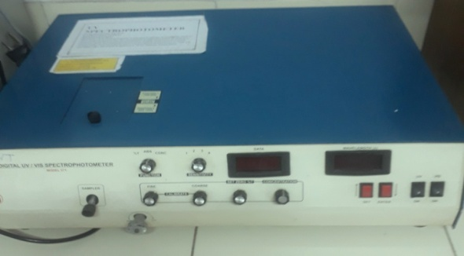  Name of the Instrument: Spectrophotometer-UV  Company Name: Systronics | 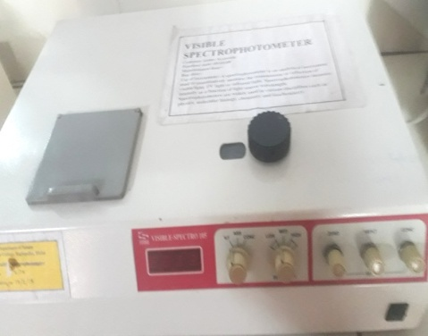  Name of the Instrument: Spectrophotometer-Visible  Company Name: Systronics
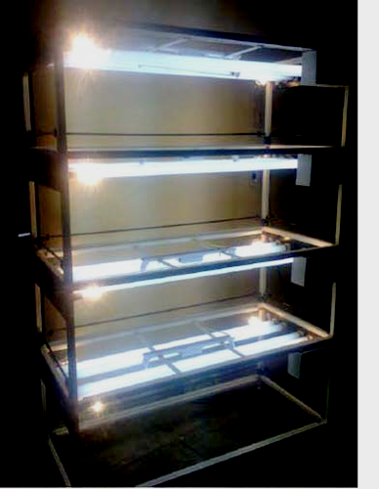  Name of the Instrument: Tissue Culture Rack  Company Name: Rescholar Equipment | 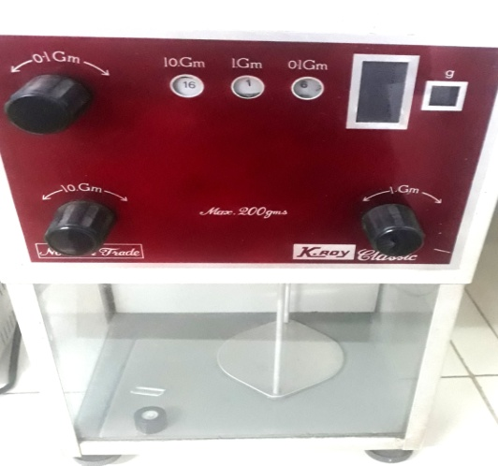  Name of the Instrument: Weighing Balance  Company Name: Keroy

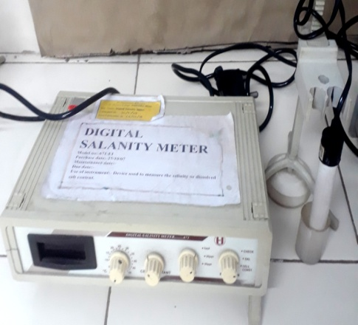  Name of the Instrument: Digital Salinity Meter  Company Name: 361 EI | 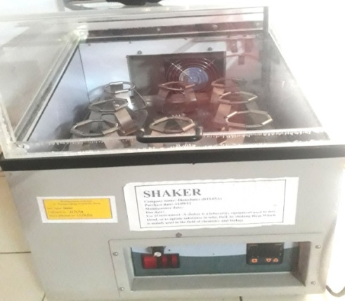  Name of the Instrument: Shaker Power Fan  Company Name: Biotechinus India
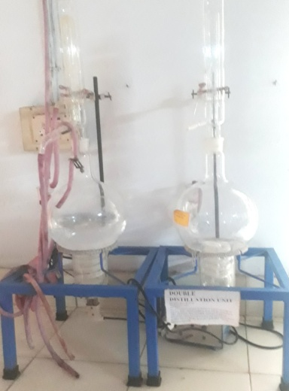  Name of the Instrument: Double Distillation Unit  Model No.: 2063/200 | 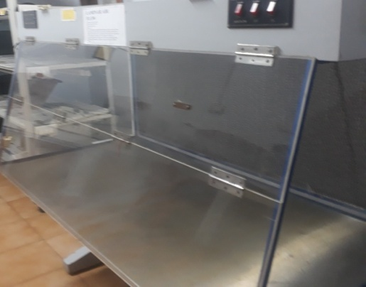  Name of the Instrument: Laminar Air Flow  Company Name: LabTech

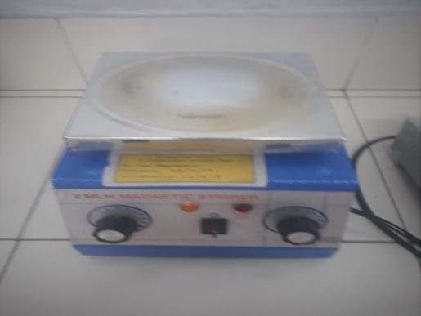  Name of the Instrument: 2 MLH Magnetic Stirrer  Company Name: LabTech | 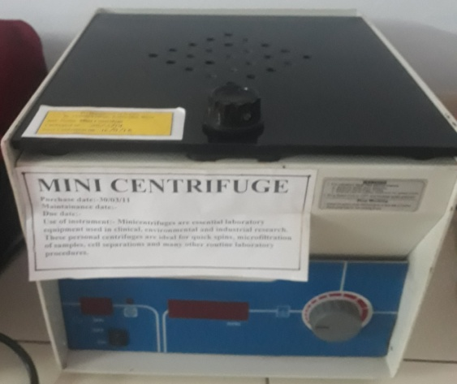  Name of the Instrument: Mini Centrifuge  Company Name: Remi
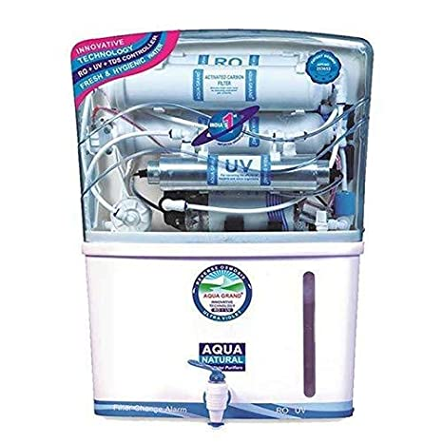  Name of the Instrument: Reverse Osmosis Water Purifier  Company Name: Aquafresh | 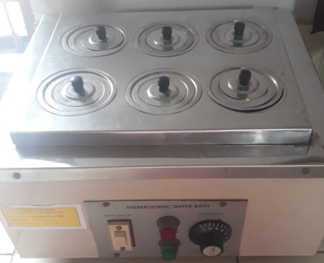  Name of the Instrument: Thermostatic Water Bath  Company Name: Anco

